
Weekly Newsletter
W.B. 7.2.22

This week:
As part of English this week we have continued their second cycle of story writing. The children have continued writing their stories moving onto the problem part which begins with ‘Suddenly’. In this section of the story, the cruel sneaky birds; Sarah and Tom create an evil plan to peck Harry’s toes in the hope that it makes him fall off the wire. After that, the children wrote their own resolution and end starting with ‘Fortunately’ and ‘In the end’ and decided how their story would be resolved and end. They had incredibly imaginative ideas for the end of their story!

Can your child tell you the story language we use for the ‘resolution of a story?
Can your child tell you what happened in the end of their story?

In Maths the children have rounded off their topic of time. The children have looked at writing the time for both the digital clock and the analogue clock. Children have had to consider carefully how to write the hours and minutes on a digital clock. This week we have also looked at the 5-minute intervals on an analogue clock. It’s really important that we can count in multiples of 5’s to be able to do this. We have drawn hands on clocks and also written the time shown on clocks containing the 5-minute intervals. E.g.:

The time is 20 minutes past 8.
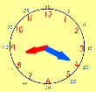

At the end of the week we went on a maths time hunt! Looking around for clocks we can find around school and recording the time in words. We loved this and found it really fun!

Can they tell you what the time would be in an hour/ half an hour/ 15 minutes later?
Can your child tell the time at home?
Can they tell you what the time will be an hour later?
Can they tell you what the time will be half an hour later?
Can they identify the hour hand and the minute hand on the clock?

The children’s topic this half term is ‘Rio De Vida’. As part of topic lessons, children are continuing their geography learning about the continents and countries within them. This week, the children have been learning about the United Kingdom (UK) and the four countries within it. They had to name and locate England, Scotland, Wales and Northern Ireland and colour them in the correct colour using a map of the UK. They then had to answer some questions about the four countries such as ‘which is the biggest country in the UK?’ and ‘which country do we live in?’. After that, we learnt about some key features of England and Brazil including The River Thames, Scafell Pike, St Michael’s Mount, Sheffield, Brazilia, Amazon Rainforest, Iguazu Falls and Copacabana Beach. We had to locate these features on our own blank map of England and Brazil and then name them on our own key. Finally, we compared the key features in England and Brazil and sorted them into a grid to determine if they were a human or physical feature.
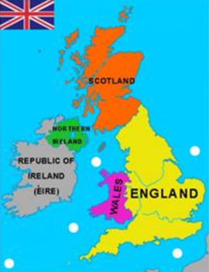
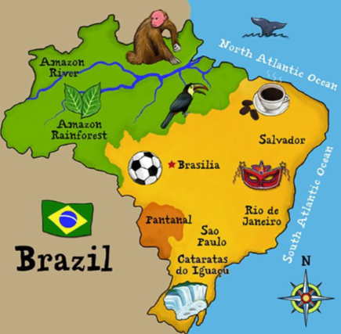

Can your child tell you which continent the UK is in?
Can your child tell you which country is to the north of England?
Can your child tell you what continent Brazil is in?

The children have also started their art learning this week. They began by learning how to use Modroc and practised by sculpting balls and horse shoes. They then worked in pairs to apply their sculpting skills to create an animal mask that you may find in our focus continent; South America! The children loved making, painting and adding features such as eyes and ears to their amazing masks!

Reminders:

Class 7 PE days are Thursday and Friday.
Class 8 PE days are Tuesday and Thursday.
Class 9 PE days are Tuesday and Friday.

Attendance for KS1:
Class 7 – %
Class 8 – %
Class 9 – %

Homework
Homework will mainly be handed out on a Wednesday. On the odd occasion it may be on a different day due to timetable changes. Please return homework on a Monday. Handing it on a Monday gives you the opportunity before the weekend to ask the teacher any questions so that you are clear of how to support your child if unsure. There is a tray in each class where the homework needs to be returned. Please ask the teacher where this tray is if unsure.

Spellings
Spellings are handed out each Thursday and your child will be tested on these spellings the following Thursday. Children will receive a list of spellings to practise each week. In addition to the spellings, children will be tested on a sentence containing the words. However, the sentence will not be sent home. This is to see if they can apply the spelling currently within their writing. Can you get your child to practise applying the words by creating their very own sentences?

Reading Diaries
Children in KS1 have all been provided with a Home Reading Diary. Please fill this in daily based on your child reading a couple of pages of a book or a whole book. Please return the Reading Diary to school each day and leave it in their book bags. There are books situated in the classroom for your child to take home daily. Reading is extremely important to your child’s development so we really encourage your child to read a book or pages of a book daily. If you are unsure of your child’s reading book colour then please ask your teacher.

Thank you
Miss Rawding, Miss Bamford & Miss Payne

