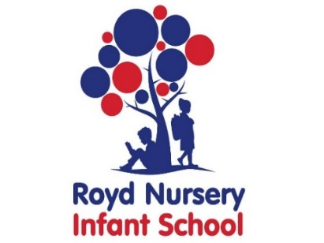

Royd Nursery Infant School

Carr Road, Deepcar

Sheffield, S36 2PR

Tel 0114 288 2594

Email [enquiries@royd.sheffield.sch.uk](mailto:enquiries@royd.sheffield.sch.uk)

[www.roydnurseryinfants.co.uk](http://www.roydnurseryinfants.co.uk)

Headteacher: Louise Jones

Dear Parent/Carers,

Towards the end of the academic year, all our Year 2 children have to sit tests/tasks called SAT’s (Standard Assessment Tests).

Miss Bamford and Miss Payne will host a parent/carer workshop on Wednesday 23 March 2022 from 5.30 pm. The session will take place via Google meets. Attendees will be advised what tests will be completed, what the format of these tests are and about the teacher assessment.

The meeting should last approximately 1 hour. If you would like to attend, please complete and return the slip below or email Ms Stuart [pstuart@royd.sheffield.sch.uk](mailto:pstuart@royd.sheffield.sch.uk) by Monday 21 March 2022. A link will be sent out on Tuesday 22 March 2022 via parentmail. Thank you.

Yours sincerely,

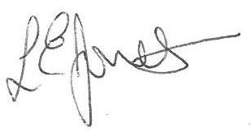



Louise Jones Sean Sly

Head Teacher Deputy Head

--------------------------------------------------------------------------------------------------------------------

**Y2 SAT’s Information Evening Wednesday 23 March 2022**

Name of Child : Class :

I / we will be attending the SAT’s Information Evening at 5.30 pm.

I/we will not be attending the SAT’s Information Evening.

Signed : ________________________________________________ Parent / Carer

Yours sincerely,

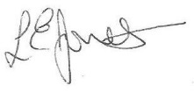

Louise Jones Sean Sly

Executive Head Acting Deputy Head



