16th March 2022
Three year old provision from Easter 2022

Dear Parents and Carers,

Thank you for being so patient whilst we organise the structure for our two and three year old provision starting after Easter.

We have children aged three attending the Nursery at Royd, Deepcar Pre-school plus new children joining. As you can appreciate we are having to work with some speed to achieve this.

Location of Provision
The Nursery building where Deepcar Pre-school are currently located, will be the base for our three year olds. This is a purpose built Nursery. Parents/Carers will drop off and collect children at the nursery building main entrance.

Transition
We are organising four to five visits that will take place beginning week 21 March 2022. This will enable children in our school setting to become familiar with the Nursery building plus children currently at Deepcar Pre-school will meet Royd staff that will be their key people after Easter. School staff have already been popping down to meet the children at Deepcar Pre-School during the past couple of weeks.

Staff
The Nursery is a school based provision and will have three full time staff members; one with a teaching degree- Miss Georgia Terry and two Teaching Assistants level 3’s, with years of experience, Mrs Charlotte Bailey and Miss Rachel Hosford.

Staggered Start
Children that currently attend Royd Nursery will start back after Easter on their normal days and times. Children attending Deepcar Pre-school and new children joining the provision will have a staggered start to help settle the two established groups together. Letters stating the day and time were issued at last night’s induction. If you have not received this letter please contact the School Office at Royd.

New starters for Nursery
An induction meeting was held last night with a stay and play session for the children at the end of March.

Meet the Teacher
Miss Terry will be contacting all the families of children in the current preschool provision to introduce herself. This will take place next week.

Parents/Carers
There will be an opportunity for parents/carers to visit the newly set up Nursery and to meet the staff after the Easter holiday.

Uniform
Children in the Nursery provision will need a school uniform. Sweaters and cardigans are on sale at the school office. Please look at the school website for all the details.
https://www.roydnurseryinfants.co.uk/uniforms-price-list/

Location and dropping off point

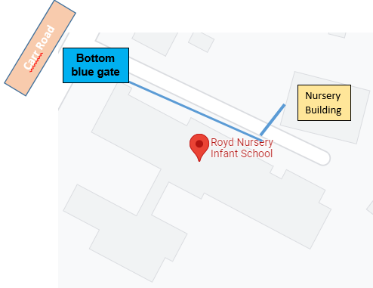

Furniture
All learning resources and furniture in the current Nursery provision at Royd will be relocated to the Nursery building during the Easter holidays plus the installation of a new interactive whiteboard.

Lunches
Children will come up to the dining room to have lunch and will be supported by school staff. Lunch will take place before the older children come to the dining room. A school dinner for nursery children is £1.75.

Toilet Training
If your child is not yet toilet trained please ensure that you work on this over the Easter holiday. If needed, Health visitors can support you with this. If you need to discuss this with staff members please talk to the Nursery staff after the Easter holiday. Thank you.

Extra sessions
If you are not entitled to the Extended Free Entitlement an additional charge for extra sessions is currently £15 per three hour session. We do have some availability after Easter if this is of interest.

If you do have any other questions please do get in touch.

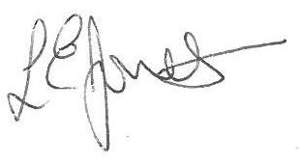
Yours sincerely,
Louise Jones
Head Teacher

