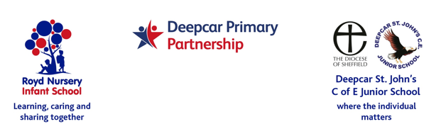
9 March 2022

Dear Parents and Carers,

I have been approached by a parent from Royd Nursery Infant to find out whether our families from both schools would like to donate some essentials for the refugees from Ukraine that have recently entered Poland.

This is a new volunteer based group called ‘Unite for Ukraine’. You may have read articles in the local papers or seen their promotion on social media groups. Their first HGV load set off from the Alhambra in Barnsley last Friday.

The schools are happy to collect these items and pass them to the volunteer group. Items that people desperately need are listed below.

Anti-diarrhoea drugs Nappies
Antiseptics Paracetamol
Baby Formula Plasters
Bandages Power banks & Cables
Batteries Raincoats
Bottled Water Shoes
Clothes Sleeping mats
Cotton wool Sore throat medications
Cough medications Thermal blankets
creams for burns, e.g. Panthenol Thermoses/Vacuum flasks
First Aid kits Toiletries
Food (non perishable) Torches/Flashlights
Food with ring pulls
Painkillers (please- no prescription drugs or any out of date drugs)

Donations can be brought during, but not before, the week Monday 21st March to Friday 25th March. You are also welcome to take your donations to them yourselves. Please bring any items to class teachers or the main office in bags or boxes. Thank you.

Yours sincerely,
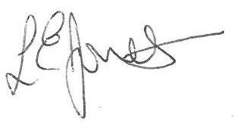
Louise Jones,
Executive Headteacher

