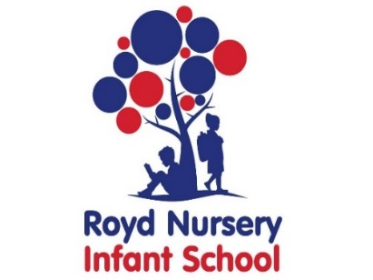

Royd Nursery Infant School

Carr Road, Deepcar

Sheffield, S36 2PR

Tel 0114 288 2594

Email [enquiries@royd.sheffield.sch.uk](mailto:enquiries@royd.sheffield.sch.uk)

[www.roydnurseryinfants.co.uk](http://www.roydnurseryinfants.co.uk)

Headteacher: Louise Jones

23 March 2022

Dear Parents/Carers

For children in FS2, Y1 and Y2 we are running several extra curricular activities during the next half term. Details are overleaf.

If you would like your child to attend please return the form below as soon as possible or email pstuart@royd.sheffield.sch.uk. Payment for activities will be requested after the half term holiday. **PLEASE DO NOT SEND CASH**. Thank you.

Yours sincerely,

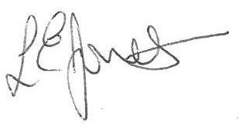

Louise Jones Sean Sly

Executive Head Acting Deputy Head

-------------------------------------------------------------------------------------------------------------------  
**Extra Curricular Activities Summer 1 2022**

Child’s Name : Class :

|  |  |  |  |  |
| --- | --- | --- | --- | --- |
| **DAY** | **ACTIVITY** | **COST** | **YEAR GROUP** | **Y/N** |
| MONDAY | CHOIR | n/a | KS1 ONLY |  |
| SCIENCE | £12 | FS2 & KS1 |  |
| TUESDAY | SEWING | £16 | KS1 ONLY |  |
| WEDNESDAY | FOOTBALL | £20 | KS1 ONLY |  |
| IMAGINATION GAMING | £20 | FS2 & KS1 |  |
| PURPLE MASH | £20 | FS2 & KS1 |  |
| THURSDAY | ARTS & CRAFTS | £16 | FS2 & KS1 |  |
| FOOTBALL | £20 | KS1 ONLY |  |
| FRIDAY | ADVENTURE ACTIVITIES / OBSTACLE COURSES | £24 | FS2 & KS1 |  |
| GARDENING | £16 | FS2 & KS1 |  |

Signed: ___________________________________________________ Parent/Carer

|  |  |  |  |  |  |  |  |  |
| --- | --- | --- | --- | --- | --- | --- | --- | --- |
| **DAY** | **ACTIVITY** | **LEADER** | **COST** | **START DATE** | **END DATE** | **YEAR GROUP** | **TAKES PLACE** | **TIME** |
| MON | CHOIR | MISS RAWDING | n/a | 25 April 2022 | 23 May 2022 | KS1 ONLY | CLASS 9 | 3.20 - 4.15 |
| SCIENCE | MISS COOPER | £12 | 25 April 2022 | 16 May 2022 | FS2 & KS1 | CLASS 6 | 3.20 - 4.20 |
| TUES | SEWING | MISS COOPER | £16 | 19 April 2022 | 10 May 2022 | KS1 ONLY | CLASS 6 | 3.20 - 4.20 |
| WED | FOOTBALL | LITTLE MESSY'S | £20 | 20 April 2022 | 18 May 2022 | KS1 ONLY | HALL | 3.30 - 4.30 |
| IMAGINATION GAMING | MISS TURNER | £20 | 27 April 2022 | 25 May 2022 | FS2 & KS1 | CLASS 6 | 3.20 - 4.20 |
| PURPLE MASH | MISS BOTHERWAY | £20 | 27 April 2022 | 25 May 2022 | FS2 & KS1 | ICT SUITE | 3.20 - 4.20 |
| THUR | ARTS & CRAFTS | MISS NEWSOME | £16 | 21 April 2022 | 12 May 2022 | FS2 & KS1 | CLASS 6 | 3.20 - 4.20 |
| FOOTBALL | LITTLE MESSY'S | £20 | 21 April 2022 | 19 May 2022 | KS1 ONLY | HALL | 3.30 - 4.30 |
| FRI | ADVENTURE ACTIVITIES / OBSTACLE COURSES | MRS HOWARD | £24 | 22 April 2022 | 27 May 2022 | FS2 & KS1 | HALL | 3.20 - 4.20 |
| GARDENING | MISS CYPHUS-FELL | £16 | 22 April 2022 | 13 May 2022 | FS2 & KS1 | OUTSIDE | 3.20 - 4.20 |