
Weekly Newsletter
W.B. 7.3.22

This week:
In Maths the children have continued their unit around addition and subtraction. Children this week have learned how to find the missing number in the middle of a subtraction calculation and at the start. The children have been exposed to the following rhymes to help them complete the missing numbers in the calculation:
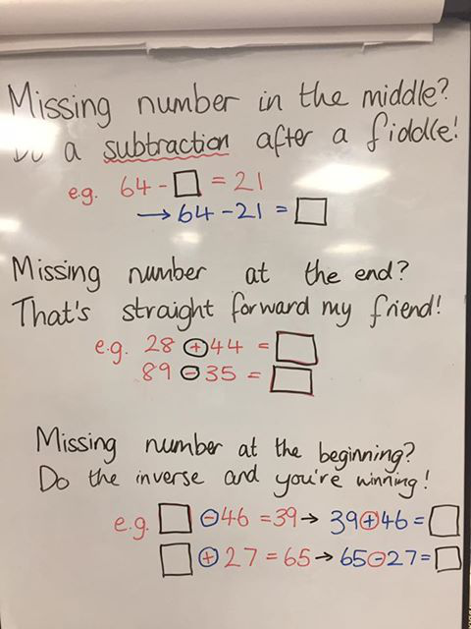

Can your child complete the following calculations using the rhymes to help them?

72 - __ = 34
__ - 16 = 57
98 - __ = 65
__ - 22 = 41

Our topic this half-term is ‘Bright Lights Big City’. As part of topic lessons, the children have started their science learning all about how we get seasons throughout the year. The children have been learning all about the Earth and how it rotates around the sun. The children loved learning about this and enjoyed the video clips that supported their learning on this.
We then moved on to our final science session of the unit by looking at day length. The children were very good at this and again loved finding out about why the length of day time differs in summer time compared to winter time.
We have had lots of talk around this and the children have thoroughly enjoyed exploring this topic.

Can your child tell you how many hours there are in a day?
Can they explain why we get seasons?
What is the weather like in each season?

Reminders:

Class 7 PE days are Thursday and Friday.
Class 8 PE days are Tuesday and Thursday.
Class 9 PE days are Tuesday and Thursday.

Attendance for KS1:
Class 7 – %
Class 8 – %
Class 9 – %

Homework
Homework will mainly be handed out on a Wednesday. On the odd occasion it may be on a different day due to timetable changes. Please return homework on a Monday. Handing it on a Monday gives you the opportunity before the weekend to ask the teacher any questions so that you are clear of how to support your child if unsure. There is a tray in each class where the homework needs to be returned. Please ask the teacher where this tray is if unsure.

Spellings
Spellings are handed out each Thursday and your child will be tested on these spellings the following Thursday. Children will receive a list of spellings to practise each week. In addition to the spellings, children will be tested on a sentence containing the words. However, the sentence will not be sent home. This is to see if they can apply the spelling currently within their writing. Can you get your child to practise applying the words by creating their very own sentences?

Reading Diaries
Children in KS1 have all been provided with a Home Reading Diary. Please fill this in daily based on your child reading a couple of pages of a book or a whole book. Please return the Reading Diary to school each day and leave it in their book bags. There are books situated in the classroom for your child to take home daily. Reading is extremely important to your child’s development so we really encourage your child to read a book or pages of a book daily. If you are unsure of your child’s reading book colour then please ask your teacher.

Thank you
Miss Rawding, Miss Bamford & Miss Payne

