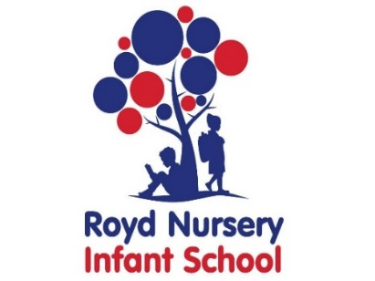

Royd Nursery Infant School

Carr Road, Deepcar

Sheffield, S36 2PR

Tel 0114 288 2594

Email [enquiries@royd.sheffield.sch.uk](mailto:enquiries@royd.sheffield.sch.uk)

[www.roydnurseryinfants.co.uk](http://www.roydnurseryinfants.co.uk)

Headteacher: Louise Jones

9 March 2022

Dear Parent/Carers

**Whirlow Residential 2022**

The Whirlow residential visit for our Year 2 children is back for 2022!!

We offered this experience for several years (before the pandemic) and each visit has been exciting and fun giving the children strong learning experiences in independence, getting on with others, seeing life on a farm and enjoying countryside activities. Views of parents/carers from previous visits have been that although they were anxious initially, were thrilled upon the children’s return at how much they had enjoyed themselves and amazed at how independent the children had become in such a short time.

The visit for each child will be for 2 days and 1 night during the period of Wednesday 15 June 2022 and Friday 17 June 2022. The cost will be approximately £50 per pupil. This covers transport there and back, accommodation and catering with activities hopefully including pony riding, farm jobs and a short local walk.

If you would like your child to go on the residential please complete and return the consent form to Mrs Stuart in the Office as soon as possible. Payment is via Parentmail and needs to be received by Thursday 31 March 2022. Thank you.

Yours sincerely,

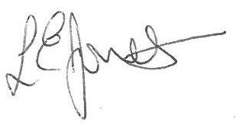

Louise Jones Sean Sly

Executive Head Acting Deputy Head





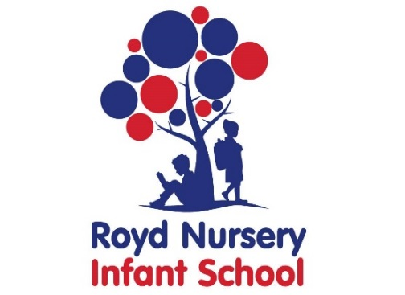

**Year 2 Whirlow Farm Residential 2022**

Child’s name : Class :

I/We would like my child to go to Whirlow Hall Farm for the residential visit during the period of Wednesday 15 June 2022 and Friday 17 June 2022 for 2 days and 1 night.

The payment of £50 has been made via Parentmail.

The payment of £50 will be made by Thursday 31 March 2022.

***I also understand that by signing this form I am providing consent for Whirlow Hall Farm to possibly use photograph’s of my child in publicity brochures.***

No, I/We do not wish for my/our child to go on the residential visit.

Signed : ___________________________________________ Parent/Carer

Date : ____________

