20th April 2022

Breakfast and Afterschool Club

Dear Parents and Carers,

Welcome back after the Easter holidays. We hope you have all had a wonderful break.

I am writing to you regarding breakfast and afterschool club bookings.

Thank you to those parents that have already completed the bookings forms.

We now have a mobile number for this provision. You can contact the staff directly on this number between 7am - 9am and 3pm - 6pm. The number is 07394223822. The email address is [breakfastandafterschoolclub@deepcarprimarypartnership.sheffield.sch.uk](mailto:breakfastandafterschoolclub@deepcarprimarypartnership.sheffield.sch.uk)

If you need to make any short notice bookings during school hours you will need to contact the school office who will let the staff know otherwise we need parents to fill in the paperwork to complete bookings. The staff running the wrap around care are working with the two year olds during school hours. There is also an email address to return the bookings and to make contact

The breakfast and afterschool provision is being run in class 6 which is the classroom opposite the hall. This can be access from the top blue gate on Carr Road. The staff will be taking the children into the dining room for a small breakfast at 8.10am ish. If you arriving at this time you will need to press the doorbell at the side of the door to the hall.

Yours sincerely

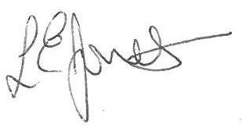

Executive Headteacher