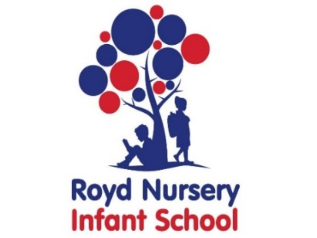

Royd Nursery Infant School

Carr Road, Deepcar

Sheffield, S36 2PR

Tel 0114 288 2594

Email [enquiries@royd.sheffield.sch.uk](mailto:enquiries@royd.sheffield.sch.uk)

[www.roydnurseryinfants.co.uk](http://www.roydnurseryinfants.co.uk)

Headteacher: Louise Jones

25 April 2022

Dear Parent/Carers,

On Friday May 13 2022 we are having a practical science afternoon for the Y1 and Y2 children and would like to invite you in to School to join in the activities with your child.

The activities will revolve around materials and building strong structures, lava lamps and a rain cloud experiment with 30 minutes at each session before moving on to the next skill.

Parent/carers need to arrive at school at 1pm for a prompt 1.10pm start and the event will finish at 3.10pm.

If you would like to join us please complete and return the slip below or email Mrs Stuart on [pstuart@royd.sheffield.sch.uk](mailto:pstuart@royd.sheffield.sch.uk). We look forward to seeing you all.

Yours sincerely,

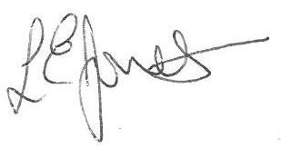



Louise Jones Sean Sly

Executive Head Acting Deputy Head

_____________________________________________________________________

**Practical Science Friday May 13 2022**

Name of child Class:

YES I/We would love to attend the practical science afternoon.

NO I/We will not be attending.

Signed ____________________________________________________ Parent/carer



