

Royd Nursery Infant School

Carr Road, Deepcar

Sheffield, S36 2PR

Tel 0114 288 2594

Email [enquiries@royd.sheffield.sch.uk](mailto:enquiries@royd.sheffield.sch.uk)

[www.roydnurseryinfants.co.uk](http://www.roydnurseryinfants.co.uk)

Headteacher: Louise Jones

9 May 2022

**Walk to School Week**

Dear Parents/Carers,

As part of schools’ commitment to **keeping healthy** and because we are a proud **Green flag awarded Eco School,** we will be taking part in National ‘Walk to/from school’ next week. This will be from **Monday 16th May** until **Friday 20th May.** Pupils across school will be encouraged to walk to and from school for the whole week. There will be a certificate awarded to the class with the most children who do this.

We understand that for some parents/carers, it is impossible to walk all of the way to and from school because of work commitments and other reasons. If this is the case, your child can still participate if you park your car further away from school than you normally do. That way, your child is still completing some of the walk.



Yours sincerely,

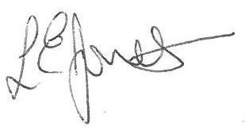



Louise Jones Sean Sly

Executive Head Acting Deputy Head



