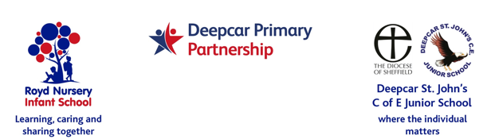

11 May 2022

Wear what makes you happy
Dear Parents and Carers,

On Friday 20th May 2022 we are asking children to come dressed in clothing that ‘makes them happy’ for a £1 donation to school fund.

It has been a while since we have made a collection for the school as we have been supporting other worldwide and national charities.

I am sure the children will enjoy this non uniform day whilst supporting the schools.

Yours sincerely,
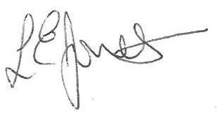
Louise Jones
Head Teacher

