
Weekly Newsletter
W.B. 2.5.22

This week:

This week in English the children have continued their story writing focus. We started off the week by learning about the suffixes ‘er’ and ‘est’. The suffix ‘er’ is used for comparing and is called a ‘comparative’ adjective and the suffix ‘est’ is used for comparing more than two things and is therefore a ‘superlative’ adjective. For example, this cake is tasty, that cake is tastier but those sweets are the tastiest. The children had to look at different words and decide which spelling rule needed to be applied.

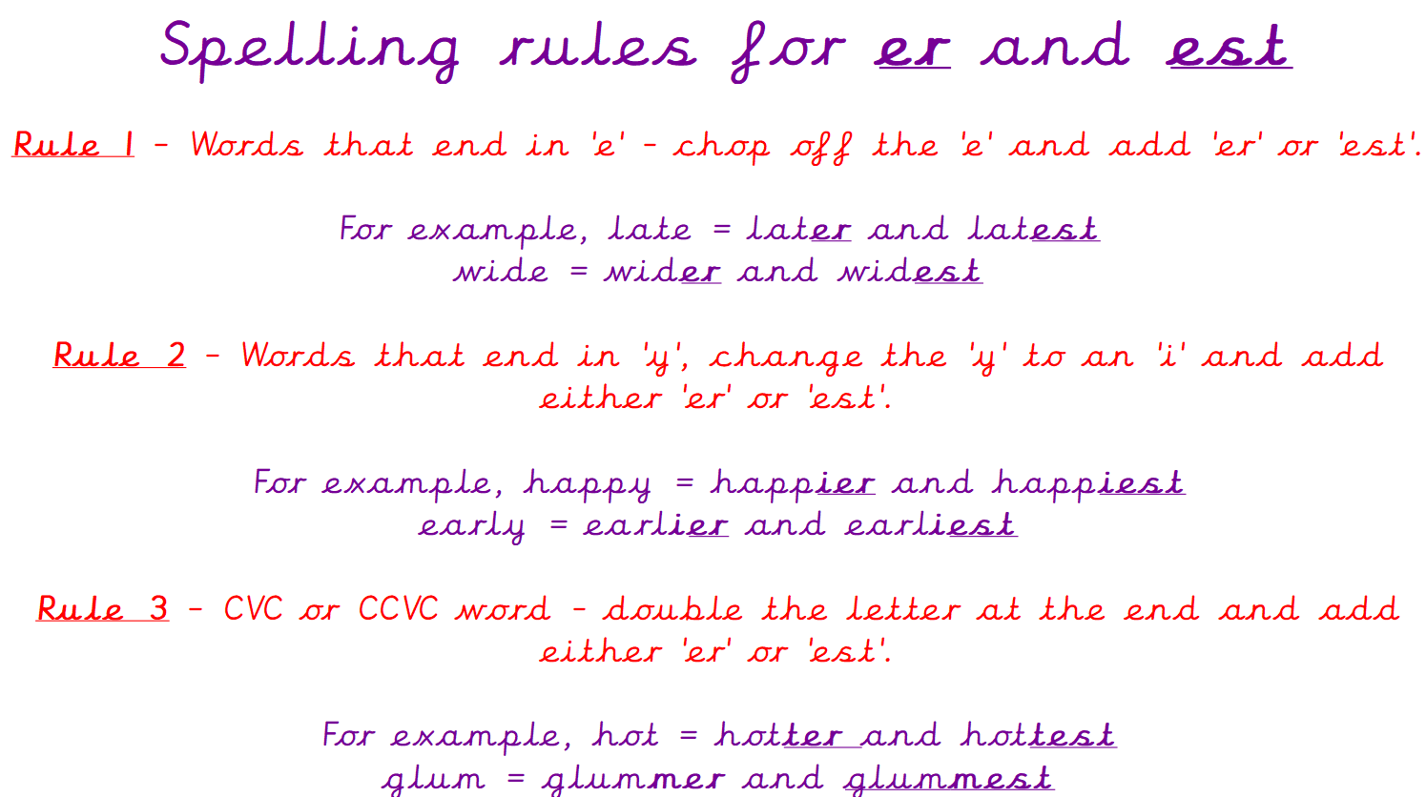

The children have also learnt about the prefix ‘un’ which is added to the start of a root word to change the meaning by giving it an opposite/negative force. We can often say the opposite of a word by adding ‘un’ for example, kind = unkind and friendly = unfriendly. There are no spelling rules for adding the prefix ‘un’ so the children simply applied it to the start of a bank of words and then used these within their sentence writing.

After that, we looked at punctuation and analysed the story to find question marks and exclamation marks. We used the story to inspire us to write our own questions based on the characters Nigel and Sarah, such as “Do we have to walk through the squelchy mud?”. We then moved onto exclamation marks and we used these in our own sentences, remembering that an exclamation mark is used to show a strong feeling or emotion, for example “Oh stop complaining!” bellowed Nigel.

Can your child tell you the spelling rules for adding ‘er’ and ‘est’?
Can your child tell you what the prefix ‘un’ does to a root word?
Can your child tell you’re their own questions and exclamation sentences?

As part of Maths this week children have continued their focus on addition and subtraction. We have been learning ho to solve missing number calculations. First, we completed addition calculations, starting from the first number, circling this on the number line and counting on to find the missing number.
When solving subtraction missing number calculations, we started with the first number and then counted backwards to the answer to find the missing number.

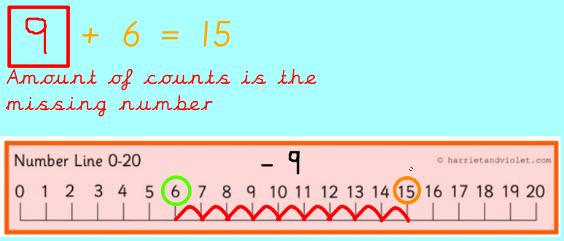
Can your child complete the following calculations using number lines?

6+___=12

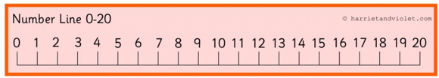
____+ 3=8

9-___=4

7-____= 3

Our topic this half-term is ‘Enchanted Woodland. As part of topic lessons, the children have continued their Science learning. They looked some more at the life cycle of a plant before planting our very own class beanstalk. We planted a broad bean seed in a clear plastic cup are going to ensure it receives light, water and warmth over the next few weeks to see how these variables affect the growth.

After that, we learnt about trees including evergreen trees, deciduous trees and how seasonal changes affect plants. The children know that an evergreen tree keeps its leaves green all year round and that deciduous trees lose their leaves seasonally. The children sorted pictures of a deciduous tree throughout the seasons into the correct boxes.

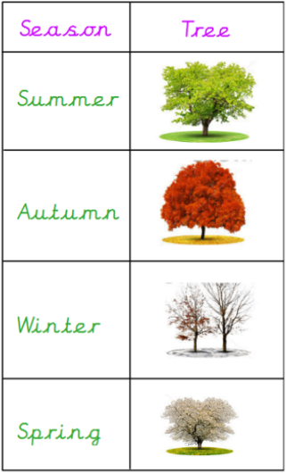

Can your child tell you how we can find out if a tree is evergreen or deciduous? (The leaves on an evergreen tree have 4 features: small, thin/pointy, strong and waxy/looks shiny)

Can your child tell you what happens to a deciduous tree in Autumn?

Reminders:

Class 7 PE days are Thursday and Friday.
Class 8 PE days are Tuesday and Thursday.
Class 9 PE days are Tuesday and Thursday.

Attendance for KS1:
Class 7 – %
Class 8 – %
Class 9 – %

Homework
Homework will mainly be handed out on a Wednesday. On the odd occasion it may be on a different day due to timetable changes. Please return homework on a Monday. Handing it on a Monday gives you the opportunity before the weekend to ask the teacher any questions so that you are clear of how to support your child if unsure. There is a tray in each class where the homework needs to be returned. Please ask the teacher where this tray is if unsure.

Spellings
Spellings are handed out each Thursday and your child will be tested on these spellings the following Thursday. Children will receive a list of spellings to practise each week. In addition to the spellings, children will be tested on a sentence containing the words. However, the sentence will not be sent home. This is to see if they can apply the spelling currently within their writing. Can you get your child to practise applying the words by creating their very own sentences?

Reading Diaries
Children in KS1 have all been provided with a Home Reading Diary. Please fill this in daily based on your child reading a couple of pages of a book or a whole book. Please return the Reading Diary to school each day and leave it in their book bags. There are books situated in the classroom for your child to take home daily. Reading is extremely important to your child’s development so we really encourage your child to read a book or pages of a book daily. If you are unsure of your child’s reading book colour then please ask your teacher.

Thank you
Miss Rawding, Miss Bamford & Miss Payne

