29th April 2022
Platinum Jubilee Celebrations
Dear parents and carers,
Across both schools we will be celebrating the Queen’s Platinum Jubilee on Friday 27th May. The Queen is the longest ruling British monarch and we wish to mark this very special occasion in school. If your child attends Nursery at the beginning of the week they will celebrate on Wednesday 25 May in the morning.
On this day we are asking children to either come dressed in their best/ garden party/royal clothes or in red/ white/ blue clothing (no football kits).
During the morning children across both schools will be completing activities linked to the Queen and the Platinum Jubilee. Younger children at Royd may complete these activities at different points during the week. Each class will also be making and sending cards to the Queen.
Children will have lunch as normal and in the afternoon we will be having street parties in the hall. Two year olds will be having their party in their own provision area.
We will be asking parents to donate some party food for this event and staff will send out requests in the week (s) leading up to the day. For any child with a food allergy we are asking parents to prepare a small box of party food for their child.
We are hoping to make this one off event as memorable as possible for your child and are all looking forward to marking this special occasion.

Yours sincerely
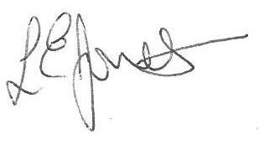
Executive Headteacher

