Royd Nursery Infant School

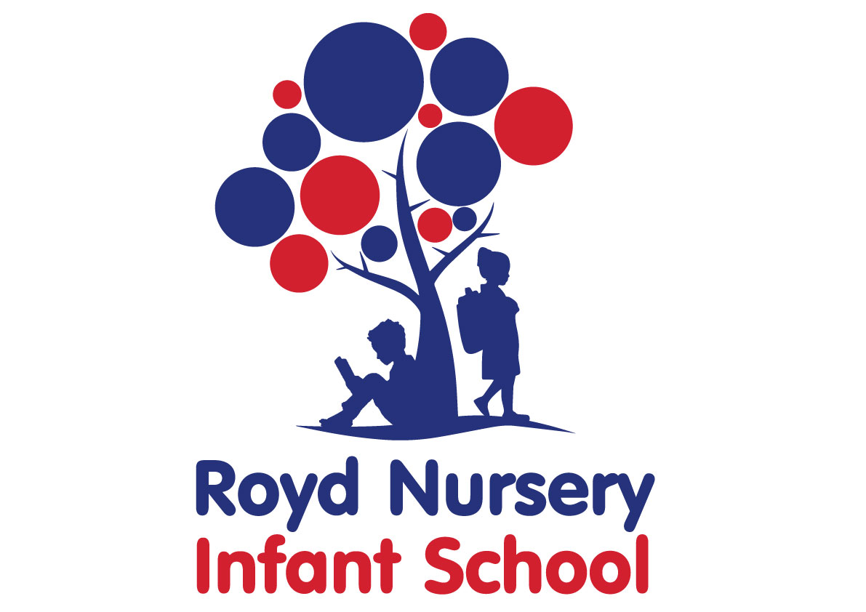

Policy: Calculation Policy

Adopted by Governing Body on | September 2022
Headteacher | Louise Jones
Date of Review | September 2023

Calculation Policy

Approach to calculation: policy & practice

Introduction

It is essential that the school has a whole school approach to calculation which has continuity and progression from the EYFS (Early Years Foundation Stage) to the end of KS1 (Key Stage 1) to enable all pupils to develop a thorough understanding of early number and achieve their potential.

The strategies the school uses are logical methods taught with the support of structured imagery which is an adaptable and inclusive maths approach suitable for children of all abilities ensuring every child can be successful in maths.

Importance is placed on:
- understanding and using correct mathematical vocabulary. When the LO is shared, questioning should elicit the extent of the pupil’s understanding. The correct vocabulary should be defined and modelled
- understanding the symbols used in number sentences
- speaking and listening and working collaboratively. All lessons should include an opportunity to discuss or explain strategies, vocabulary etc ‘Talking partners’ should be planned for to allow pupils to work out a solution together or explain a procedure etc

All lessons should follow the structure ‘review, teach, practice, use and apply and assess’. They should cater for visual, auditory and kinaesthetic learners and include demonstrating and modelling. Ensuring the learning is put into context is particularly important to ensure pupils use and apply their knowledge and skills.

At the EYFS and KS1, calculation is a mixture of practical, oral and mental work.
However, they will make use of written forms to:
- make a record in pictures, words or symbols of calculation activities that they have already carried out, and to construct number sentences
- explain to someone else what they have done
- interpret information that requires practical, oral or mental calculation
- help work out steps in a calculation they will later do entirely mentally.

Calculation
Much of young children’s work with calculation will be oral, arising from practical activities. Talking about what they have done is a precursor to recording.

In the EYFS number activities should be planned for in all 7 areas of learning and aspects within each area. For examples: sand; water; role play; stories; music; art etc. There should be indoor and out door activities to develop learning about number.

All calculations should be taught in the context of word problems from the start to develop understanding. The emphasis should be on problem solving where children can explain their reasoning rather than straight forward number sentences throughout.

Children should have experience of finding their own ways of recording calculation. Understanding should be sound before conventional recording is introduced.

Addition

Counting all

Children should be challenged to solve addition problems in all areas of provision in the EYFS.

There are 6 black sheep and 4 white sheep. How many sheep are there altogether?
Michael dropped 4 x 1p into the box. Ben dropped 3p in. How much is in the box?
Make a tower of 7 red bricks and 3 yellow bricks. How many bricks are in the tower now?
There are 3 girls and 2 boys in the team. How many children are in the team?

These activities should be modelled and demonstrated to individuals, small groups and the whole class as children progress throughout the EYFS.

Relate addition to counting on

Lessons should include comparisons of counting all and counting on to demonstrate efficiency and develop understanding.

Lessons should include working out the calculation using given number lines 0-10, 0-20, 0-30 and mentally also (tap head).

Pupils should work with teen numbers and higher numbers to develop counting on skills and an early understanding of place value.

10+ 1, 10+ 2, 10+ 3, 50 +2, 60+7 etc

Resources such as bead strings, place value arrow cards, 100 squares and number lines should be used.

Addition is commutative

Lessons should demonstrate that 2+50 is the same as 50+2. Which is quicker/more efficient?

Reordering

3+ 6 + 41= largest first
41+ 6+ 3 =

7+ 4 + 7 = using doubles
14 + 4 = (pupils should know doubles by heart- otherwise it is not particularly efficient)

7 + 20 + 3 = using number bonds
20 + 10 = (pupils should know bonds by heart- otherwise it is not particularly efficient)

Add a multiple of 10 to a one or two digit number

Pupils should begin to use informal methods (empty number line)
+10 +10 +10

46 +30 =
46 56 66 70

There should be discussions around how it is easier to draw a number line concerning the relevant numbers, rather than have a number line 0-100 on the table etc

Add a near multiple of 10 to a two digit number
+10
-1

46 + 9 =

46 55 56

Informal methods: empty number line

+10 +10 +1

46 + 21 =

46 56 66 67
Add 2 two digit numbers

Informal methods:

Numicon




+
=
23
14 37

empty number line

When using ‘empty number lines’, start with the larger number and count on.

First counting on in tens and ones.

34+23 = 57

+10 +10 +1 +1 +1

34 44 54 55 56 57

Then helping children to become more efficient by adding the units in one jump (by using the known fact 4 + 3 = 7).

34+23 = 57

+10 +10 +3

34 44 54 57

Followed by adding the tens in one jump and the units in one jump.

+30
+8

46 + 38 =
46 76 84

Bridging through ten can help children become more efficient.

37+15 = 52

+10 +3 +2

37 47 50 52

Continue to use empty number lines with increasingly large numbers.

38+ 86 =126

+30 +4 +4

86 116 120 124

Partition and recombine
Pupils should begin to use informal pencil and paper methods (jottings) to support, record and explain partial mental methods building on existing mental strategies.

34 + 65 =

60 + 30 = 90
5 + 4 = 9
90 + 9 = 99

46 + 38 =
40 + 30 = 70
8 + 6 = 14
70 + 10 + 4 = 84

Then begin to prepare for a more formal method:

34 + 65 =

60 + 30 = 90
5 + 4 = 9
90 + 9 = 99

76 + 38 =
70 + 30 = 100
8 + 6 = 14
100 + 10 + 4 = 114

Extend to:

65 + 34 =

60 5
30 4
90 + 9 = 99

46 + 38 =

40 6
30 8
70 + 14 = 84

254 + 137 =

200 50 4
100 30 7
300 + 80 + 11 = 391

Taken from NC:

Subtraction

Counting out

Children should be challenged to solve subtraction problems in all areas of provision in the EYFS.

There are 6 sheep in a field. 2 walk away. How many are left in the field?
Michael has 10p in the box. He takes 3p out. How much is in the box now?
Make a tower of 7 bricks. Make the tower 3 bricks shorter. How many bricks are in the tower now?
There are 8 girls in a line. 5 leave the line. How many are in the line now?

These activities should be modelled and demonstrated to individuals, small groups and the whole class as children progress throughout the EYFS.

Relate subtraction to counting back

Lessons should include comparisons of counting out and counting back to demonstrate efficiency and develop understanding.

Lessons should include working out the calculation mentally also (tap head).

Using given number lines 0-10, 0-20, 0-30

Pupils should work with teen numbers and higher numbers to develop counting back skills and an early understanding of place value.

11 - 1, 12 - 2 , 13 - 3, 52 - 2, 65 - 5 etc

Using number lines, 100 squares, place value arrow cards, bead strings etc

Find the difference between 2 numbers by counting forward

The difference between 16 and 20 is 4

16 is 4 less than 20
20 is 4 more than 16

Relate subtraction to counting forward (find the difference between)

Lessons should include demonstrations to show that 20 – 17 can be calculated by counting backwards or forward but forwards is more efficient.
Use a ‘difference between grid’ and cubes.

Know that subtraction is the inverse of addition (and vice versa)
(derive other number facts from a given number sentence)

If 6 + 4 = 10, what 2 subtractions facts do you know?

Vary the order of the number sentence:
6 + 4 = ?
? = 6 + 4

Use cubes, pegs etc (2 colours)

Subtract a multiple of 10 from a two digit number

Pupils should begin to use informal methods (empty number line)

-10 -10 -10

46 -30 =
16 26 36 46

Subtract a near multiple of 10 from a two digit number

46 - 9 =
46-10+1= or use an empty number line
-10
+1

36 37 46

46 - 21 =
-20
-1

25 26 46

Subtract a two digit number from a two digit number

Numicon

 - = 

Counting back on a number line

47 – 23 = 24

-1 -1 -1 -10 -10

24 25 26 27 37 47

Teaching children to become more efficient by subtracting the units in one jump (by using the known fact 7 – 3 = 4).

47 – 23 = 24

-3 -10 -10

24 27 37 47

Subtracting the tens in one jump and the units in one jump.

47 – 23 = 24

-3 -20

24 27 47

Bridging through ten can help children become more efficient.

47 – 25 = 17

-3 -2 -20

17 20 22 42

Where the numbers involved in the calculation are close together or near to multiples of 10, 100 etc counting on using a number line should be used.
+5 +10
+7 =22

87 – 65 =
65 70 80 87

Partitioning and decomposition

When solving the calculation 52 - 28, children should know that 28 does not exist as an amount, it is what you are subtracting from the other number. Therefore, only the lower number needs to be partitioned.

52 – 28 =

52 – 20 = 32
32 – 8 = 24
Taken from NC

Multiplication

Multiplication is when objects or numbers are combined in equal groups. It is usually associated with repeated addition but it can also involve the idea of ‘multiplying factor’ such as when one set has ‘four times as many’ or one measurement is ‘four times as big’.

Vocabulary should be introduced gradually to complement the context of the problem. For example: 4 children have 2 pencils each. How many pencils are there altogether? This should be referred to as 4 lots of 2 or 4 groups of 2.

A wide range of vocabulary should be introduced over time: ‘times, multiply, multiplied by, multiple of, as well as the ‘x’ symbol.

‘Double’ should also be introduced at an early stage.

Children should be challenged to solve multiplication problems in all areas of provision in the EYFS.

Introduce multiplication through stories, rhymes when possible or appropriate.

Children will experience equal groups of objects.

They will count in 2s and 10s and begin to count in 5s.
They will work on practical problem solving activities involving equal sets or groups.

There are 3 sheep and 3 pigs and 3 horses in the field. How many animals are there altogether?

Michael dropped 4p into the box. Ben dropped 4p in. Kelly dropped 4p in. How much is in the box?

Make a tower of 3 red bricks and 3 yellow bricks and 3 blue bricks. How many bricks are in the tower now?

Make a tower 3 times as high as this one (4cubes).

Put 5 times as much in this purse (2p).

These activities should be modelled and demonstrated to individuals, small groups and the whole class as children progress throughout the EYFS.

Understand multiplication as repeated addition

5 added together 3 times is 5+5+5
or 3 lots of 5
or 3 groups of 5
or 3 times 5
or 3x5
or 5 times 3
or 5x3

Use cubes, counters, peg boards, draw arrays, draw pictures in arrays (draw in an organised format) etc

Repeated addition can be shown easily using Numicon, a bead bar or a number line:

5 x 3 = 5 + 5 + 5 
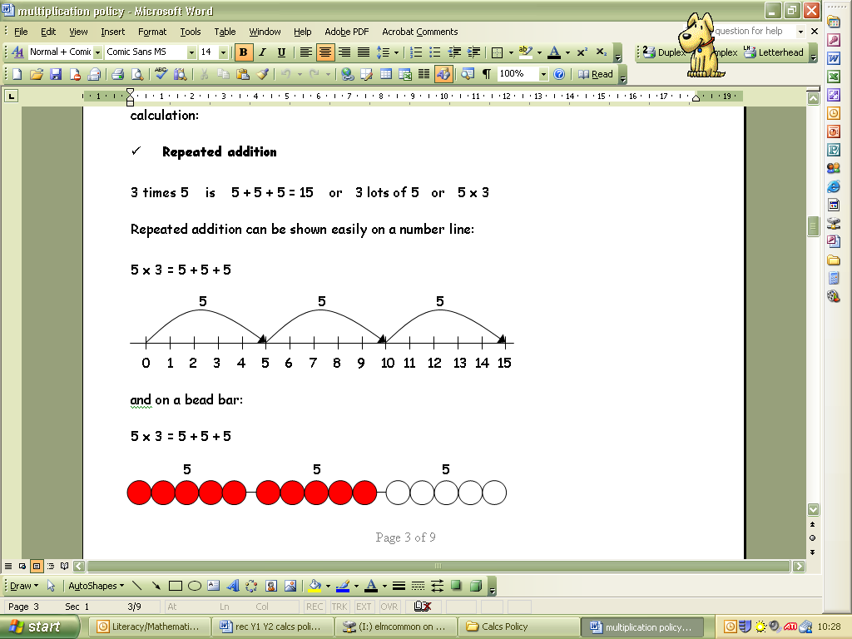

+5 +5 +5

5 + 5 + 5
0 5 10 15

Children should know that 3 x 5 has the same answer as 5 x 3. This can also be shown on the number line
+5 +5 +5

5 + 5 + 5
0 1 2 3 4 5 6 7 8 9 10 11 12 13 14 15

Arrays
Children should be able to model a multiplication calculation using an array. This knowledge will support with the development of the grid method.

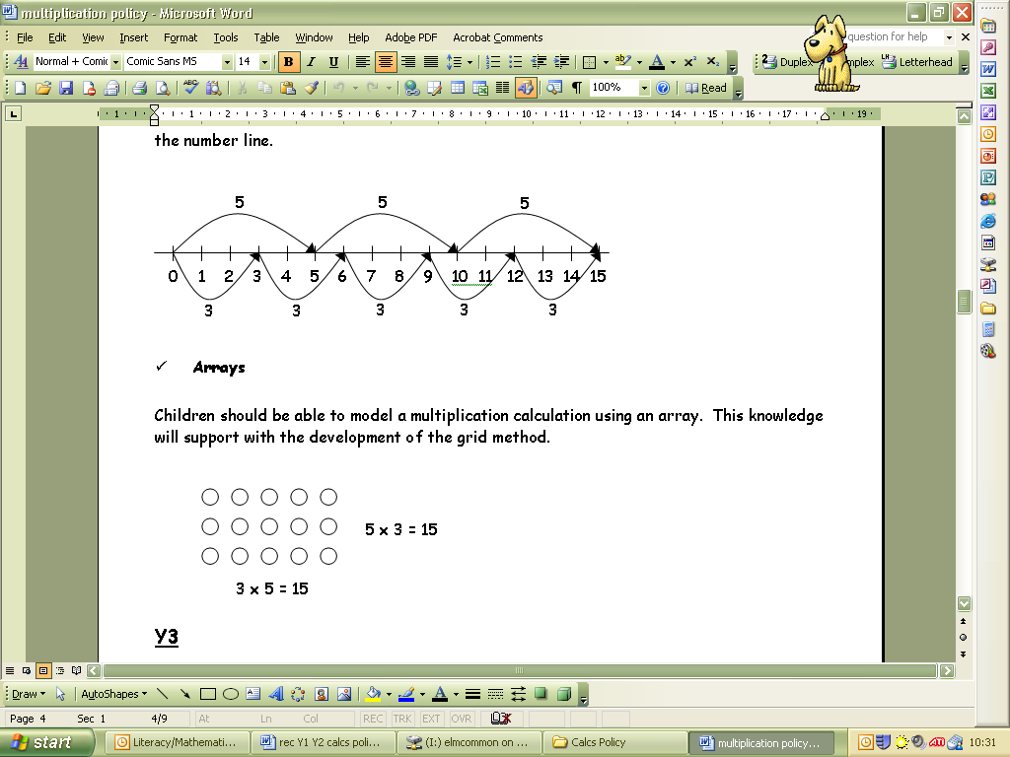
5 x 3 = 15
3 x 5 = 15

Children should be able to model a multiplication calculation using an array. This knowledge will support with the development of the grid method.

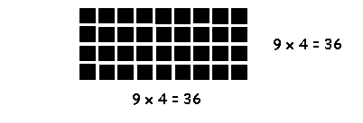
4 x 9 = 36
9 x 4 = 36

Pupils should solve multiplication problems mentally using 2s 5s 10s tables they have learnt by heart or using an empty number line.

What is the total value of 7 2ps ?

Using symbols to stand for unknown numbers to complete equations using inverse operations

 x 5 = 20 3 x  = 18  x  = 24

Partitioning
Using knowledge of place value (partition and recombine)

6 children have 14 p each. How much altogether?

Using a number line:

6 x 14 =

6 x 10 = 60 6 x 4 = 24

+60
+24

0 60 84

Using an array:

6 x 14 =

6x 10=60
6x4=24
60+24=84p

Then move onto the grid method
18 x 5
x | 10 | 8
5 | 50 | 40

New NC: Solve short multiplication
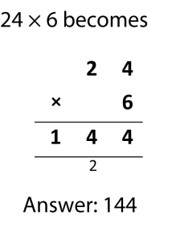

Division

Division is introduced whenever objects or numbers are partitioned in equal groups. Division is associated with repeated subtraction or with sharing equally.

Children should be taught a wide range of vocabulary associated with division. Written recording should include a range of appropriate words, phrases and symbols.

Introduce division through stories, rhymes, songs when possible or appropriate.

10 fat sausages sizzling in the pan. 1 went pop and another went bang.

Michael has 12p in his money box. He wants to share it with Ben. How much will they have each?

Make a tower of 10 bricks. How many children can take 2 bricks?
These activities should be modelled and demonstrated to individuals, small groups and the whole class as children progress throughout the EYFS.

Division as grouping

Understand equal groups and share items out in play and problem solving. .

There are 12 sweets in a bag. How many bags of 3 sweets can you make?

○ | ○ | ○ | ○
○ | ○ | ○ | ○
○ | ○ | ○ | ○

Division as sharing

There are 15 sweets in a bag. 3 children share them equally. How many sweets do they each have?

Division is the inverse of multiplication (and vice versa)

Using symbols to stand for unknown numbers to complete equations using inverse operations

6 x 3 =18 ÷ 3 = 6 18 ÷ = 3

Repeated subtraction on a number line

24 ÷ 4 = 6
0 4 8 12 16 20 24

New NC: Solve short division

Calculations involving remainders.

13 ÷ 4 = 3 r 1
4 4 4

46 +30 =
0 1 5 9 13

New NC: Solve short division involving remainders

