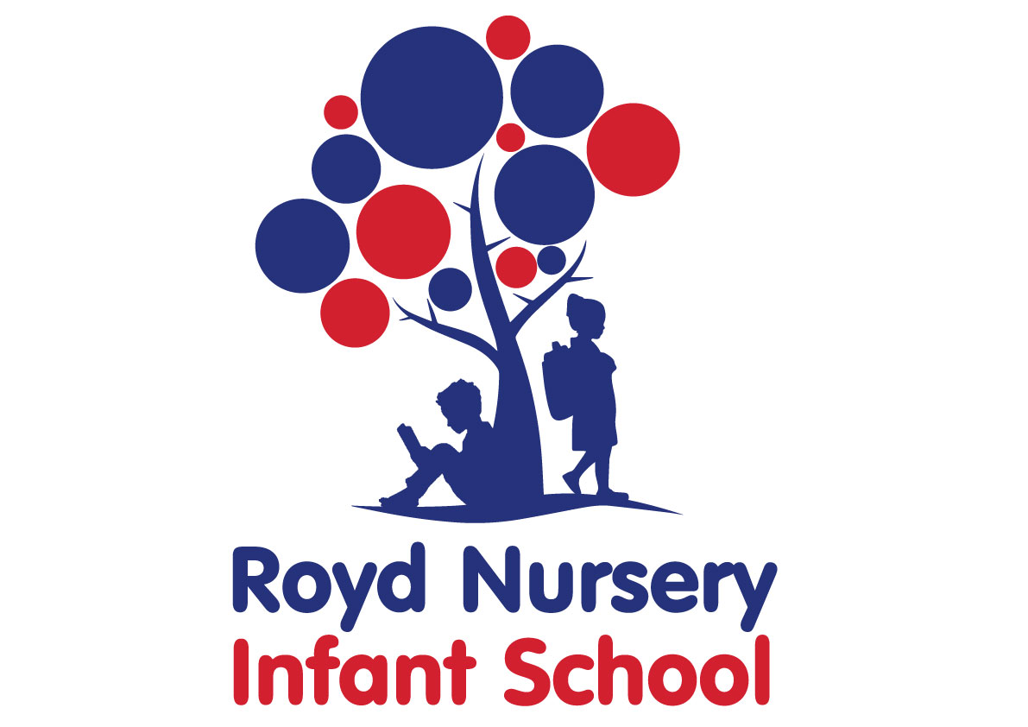

Policy: Calculation Appendix

Adopted by Governing Body on | September 2022
Headteacher | Louise Jones
Date of Review | September 2023

Year  Group Suggested | Addition | Subtraction | Multiplication | Division
EYFS | Children are encouraged to develop a mental picture of the number system in their heads to use for calculation.  They develop ways of recording calculations using pictures, etc.  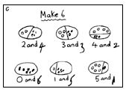  Numicon, bead strings or bead bars can be used to illustrate addition    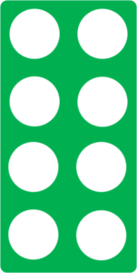  8+2=10  They use number lines and practical resources to support calculation and teachers demonstrate the use of the number line.  They use frames to investigate the numbers that make a number.  2+2=4  2+3=5  6+4=10 | Children are encouraged to develop a mental picture of the number system in their heads to use for calculation.  They develop ways of recording calculations using pictures etc.  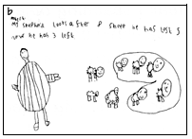  The use of real objects, cubes, Numicon or the use of a bead string can be used to illustrate subtraction.  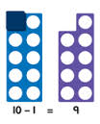  6-2=4  They use number lines and practical resources to support calculation. Teachers to demonstrate the use of the  number line.  They make links between addition and subtraction using frames.  6+4=10  10-6=4  10-4=6 | Children experience equal groups of objects.  They will work on practical problem solving activities involving equal sets or groups.  Vocabulary should be introduced gradually to complement the context of the problem. For example: 4 children have 2 pencils each. How many pencils are there altogether? This should be referred to as 4 lots of 2 or 4 groups of 2.  A wide range of vocabulary should be introduced over time: ‘times, multiply, multiplied by, multiple of, as well as the ‘x’ symbol.  ‘Double’ should also be introduced at an early stage.  They will begin to count in 2s and 10s and then in 5s.  They count in 2’s using a frame. | Introduce division through stories, rhymes, songs when possible or appropriate.  Children will understand equal groups and share items out in play and problem solving. They will count in 2s and 10s and later in 5s.
Y1+Y2 | Bead strings or bead bars can be used to illustrate addition including bridging through ten by counting on 2 then counting on 3.  8+5=13  They use Numicon, number lines and practical resources to support calculation.   +  =   13 + 4 = 17  Children then begin to use numbered lines to support their own calculations using a numbered line to count on in ones.  Children will begin to use ‘empty number lines’ themselves starting with the larger number and counting on.  First counting on in tens and ones. Numicon can also be used to deepen understanding.  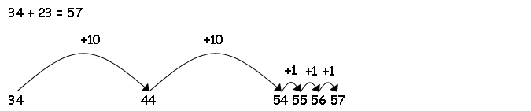  + =  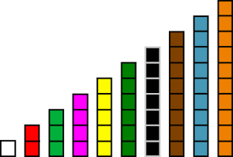  Children will learn that two parts make a whole. Cuisenaire rods can be used to support this.  B  C  A  A=B+C | Bead strings to illustrate subtraction including bridging through ten by counting back 3 then counting back 2.  13-5=8  Children then begin to use numbered lines to support their own calculations - using a numbered line to count back in ones.  The number line should also be used to show that 6 - 3 means the ‘difference between 6 and 3’ or ‘the difference between 3 and 6’ and how many jumps they are apart.  Children begin to use empty number lines to support calculations.  Counting back in tens and ones.  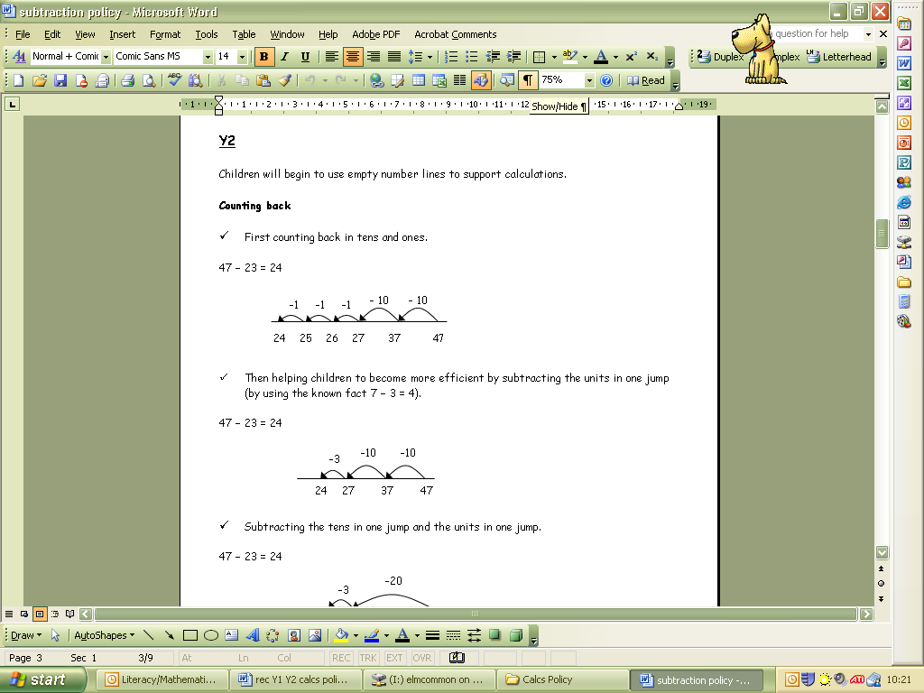  - =  Children will use Cuisenaire rods to develop their understanding of subtraction.  C  B  A  B=A-C  C=A-B | Children will continue to count in 2s, 10s and 5s.  They will work on practical problem solving activities involving equal sets or groups.  Repeated addition can be shown easily using Numicon, a bead bar and a number line:  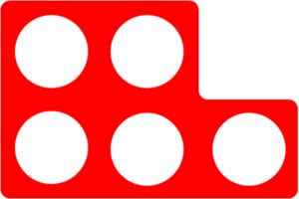  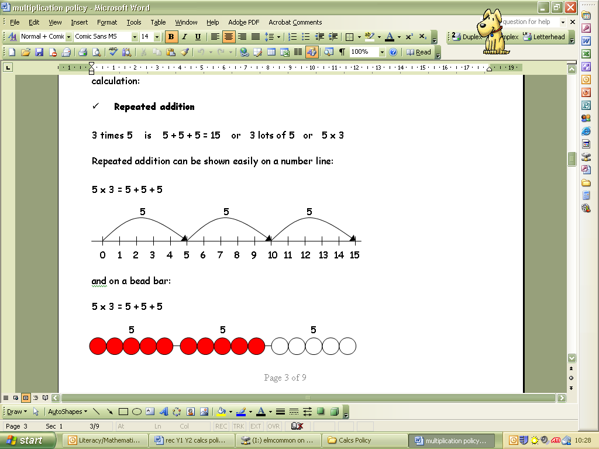  Cuisenaire rods can be used to support their repeated additions.  3+3+3+3=12 | Children continue to understand equal groups and share items out in play and problem solving.  Sharing equally  6 sweets shared between 2 people, how many do they each get?  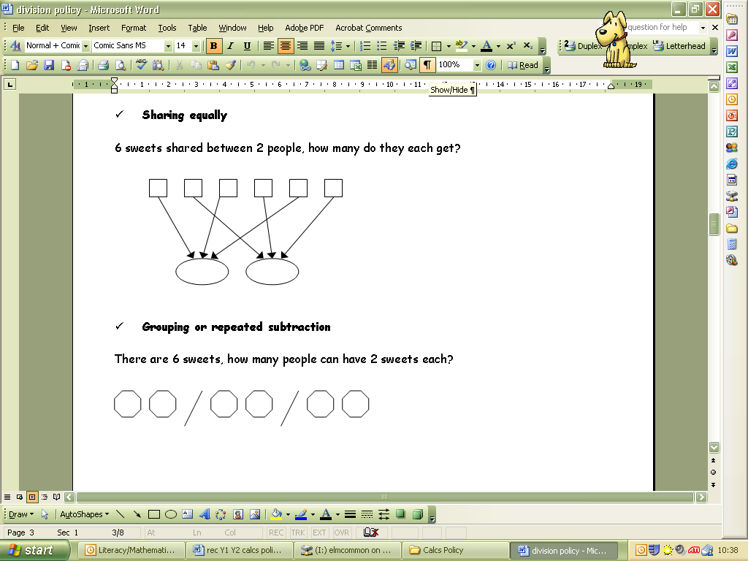  Cuisenaire rods can be used to find out how many of a number are within a number.  How many 3s in 9?
 | Children continue to use Numicon and ‘empty number lines’ themselves starting with the larger number and counting on.  First counting on in tens and ones.  Then helping children to become more efficient by adding the units in one jump (by using the known fact 4 + 3 = 7).  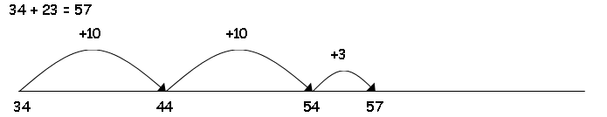  Followed by adding the tens in one jump and the units in one jump.  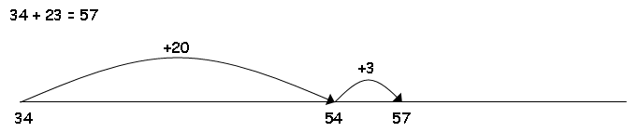  + = + =  Bridging through ten can help children become more efficient.  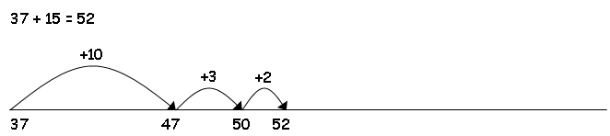  Children will continue to use empty number lines with increasingly large numbers.  Count on from the largest number irrespective of the order of the calculation.  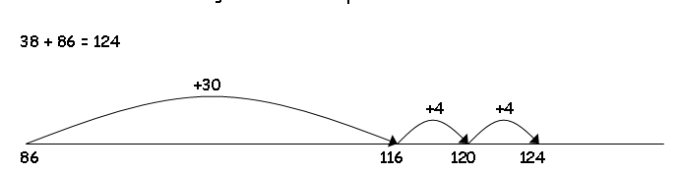  Children will begin to use informal pencil and paper methods (jottings) to support, record and explain partial mental methods building on existing mental strategies. | Continue to use empty number lines to support calculations.  First counting back in tens and ones.  Then helping children to become more efficient by subtracting the units in one jump (by using the known fact 7 – 3 = 4).  Subtracting the tens in one jump and the units in one jump.  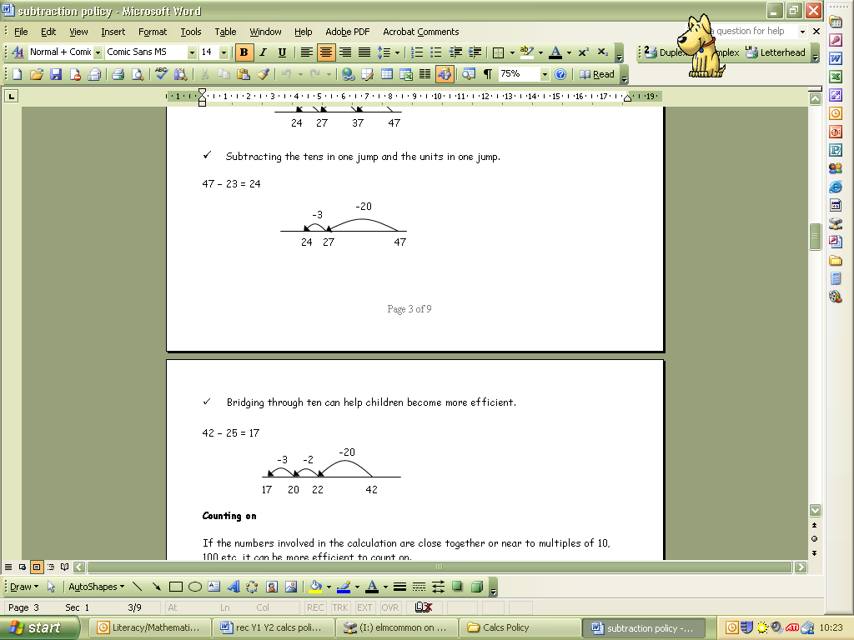  Bridging through ten can help children become more efficient.  Children continue to use empty number lines with increasingly large numbers.  Partitioning and decomposition  When solving the calculation 52 - 28, children should know that 28 does not exist as an amount, it is what you are subtracting from the other number. Therefore, only the lower number needs to be partitioned.  52 – 28 =  52 – 20 = 32  32 – 8 = 24 | Children will continue to develop their understanding of multiplication and use jottings to support calculation:  Children should know that 3 x 5 has the same answer as 5 x 3. This can also be shown on the number line.  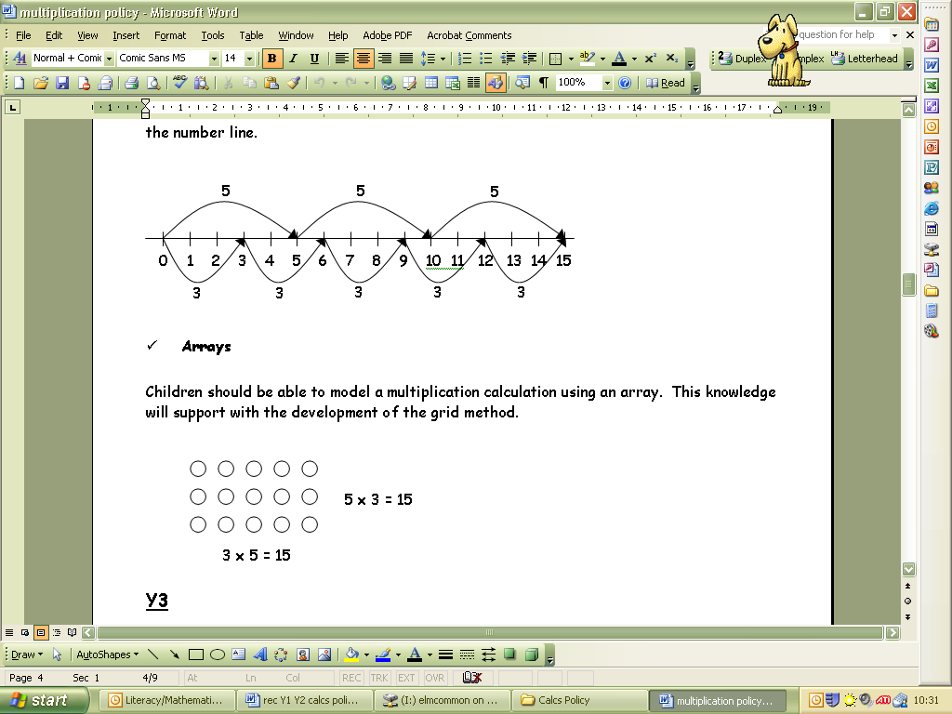  Arrays  Children should be able to model a multiplication calculation using an array. This knowledge will support with the development of the grid method.  Pupils should solve multiplication problems mentally using 2s 5s 10s tables they have learnt by heart or using an empty number line.  Using symbols to stand for unknown numbers to complete equations using inverse operations   x 5 = 20 3 x  = 18  x  = 28  Partitioning  6 children have 14 p each. How much altogether?  Using a number line.  6 x 14 =  6 x 10 = 60 6 x 4 = 24  + 60 +24  0 60 84  Using an array  6 x 14=  6x 10=60  6x4=24  60+24=84p | Emphasis in Y2 is on grouping rather than sharing.  Grouping or repeated subtraction  There are 6 sweets, how many people can have 2 sweets each?  Repeated subtraction using a number line or bead bar  12 ÷ 3 = 4  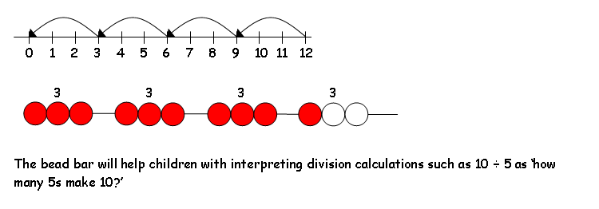  Using symbols to stand for unknown numbers to complete equations using inverse operations   ÷ 2 = 4 20 ÷  = 4  ÷  = 4  Children should also move onto calculations involving remainders.  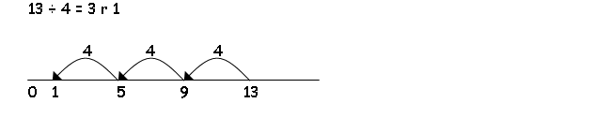  Using symbols to stand for unknown numbers to complete equations using inverse operations  26 ÷ 2 =  24 ÷  = 12  ÷ 10 = 8  Children develop their use of repeated subtraction to be able to subtract multiples of the divisor. Initially, these should be multiples of 10s, 5s, 2s and 1s – numbers with which the children are more familiar.

