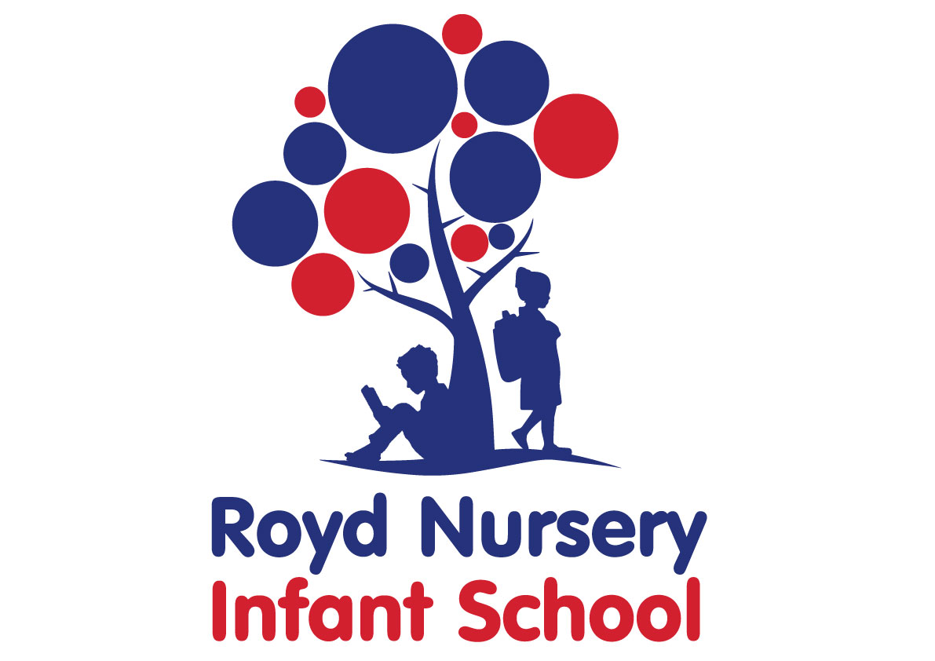

School Vision, Aims, Ethos and Values Statement

Adopted by Governing Body on | September 2022
Headteacher | L Jones
Date of Review | September 2023

Vision

Royd Nursery Infant School is a welcoming school where the children are happy to start on the road of lifelong learning that is often steered by their own suggestions.
The staff, governors and parents have a strong relationship that ensures all pupils become confident, happy, independent, respectful, responsible and motivated individuals.
We encourage children to strive to achieve their best and have high expectations of them in all areas of life.

Motto

“Learning, caring and sharing together”

Aims

For our pupils to:
- Communicate confidently through talking, listening, reading and writing
- Think for ourselves and make decisions
- Achieve their maximum potential in all subjects
- Be safe and secure in a happy and healthy environment that is well cared for
- Work independently and collaboratively with each other
- Show respect, care and consideration for others
- Work together with parents/ carers and the community to enrich and enhance learning

Ethos

Royd Nursery Infant School is a small school with a family ethos. There is a positive atmosphere because everyone works hard and has strong team work skills. The staff works tirelessly to ensure children achieve their potential
The staff are committed to continuing the strive to achieve best quality teaching and learning to meet all pupils needs.

Values

The core values
- Achieve your potential
- Make good choices
- Be responsible
- Be considerate
- Do your best
- Take pride
- Collaborate
- Respect others

