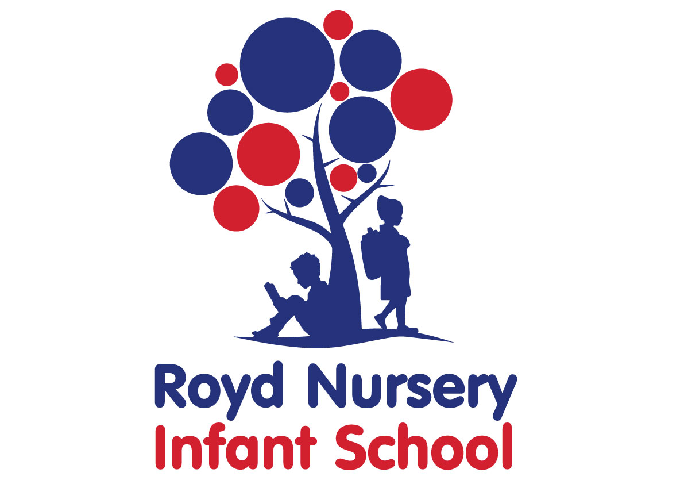

Policy: Relationships and Sex Education

Adopted by Governing Body on | September 2022
Headteacher | L Jones
Date of Review | September 2023

Relationships and Sex Education (RSE) Policy for Schools

1. Rationale and ethos

This policy covers Royd Nursery Infant School’s approach to relationships and sex education (RSE). These subjects meet statutory obligations as outlined in revised Department for Education statutory guidance (2019). The guidance states that from September 2020, all schools must deliver relationships education (in primary schools), relationships, and sex education (in secondary schools). Additional requirements on schools in law that have informed this policy and our approach include the Equality Act (Equality Act 2010: advice for schools) and Keeping Children Safe In Education – Statutory Safeguarding Guidance (2016).

We define relationships and sex education as the building blocks needed for positive and safe relationships, including with family, friends and online, and at the appropriate time to sexual health and developing intimate relationships. This includes the importance of treating others and ourselves with kindness, consideration and respect. In Our Infant School, these areas are covered to age appropriateness of the pupils who attend the school.

Royd Nursery Infant School’s Mission Statement

Our Mission statement applies to all areas of pupils’ development and learning. We believe relationships and sex education plays a key part in providing children and young people with the knowledge that enables them to make informed decisions about their wellbeing, health and relationships and to build their self-efficacy. Everyone faces difficult situations in their lives. These subjects can support young people to develop resilience, to know how and when to ask for help, and to know where to access support. Ultimately, helping our young people to be happy, healthy and safe now and in the future.

Aims and Objectives

At Royd Nursery Infant School, our aim in teaching RSE is to ensure that our children learn to:

- Cope with physical and emotional development as they grow
- Understand about human reproduction in an age appropriate way
- Understand the importance of family life, but that there are different types of family
- Respect difference and diversity
- Develop life skills relevant to relationship behaviours e.g. communication, conflict resolution, decision-making, assertiveness, responsibility and kindness
- Develop positive relationships, a sense of mutual respect and care for others; compassion
- Deal with fears and anxieties about the process of growing up and develop resilience
- Understand they have rights over their own bodies and how to keep themselves safe
- Challenge prejudice

The objective of Relationship and Sex Education (RSE) is to help and support pupils through their physical, emotional, spiritual and moral development.
A successful programme of RSE firmly embedded in PSHE (Personal, Social and Health Education), will help young people learn to respect themselves and others and move with confidence from childhood through adolescence to adulthood.
All staff, parents, children and appropriate outside agencies will work in partnership to ensure that the above objective is achieved.
We aim to help our children by ensuring that they have entitlement to Relationship and Sex Education within the curriculum as part of the PSHE scheme of work.

2. Teaching and Learning

- Delivery, monitoring and evaluation

Our RSE programme is an integral part of our whole school PHSE education provision.
RSE will be taught across the curriculum in regular sessions. Although specific topics will be addressed, other areas may arise incidentally and will be treated with sensitivity. Staff will use a variety of teaching strategies and approaches in keeping with the maturity of the pupils Through RSE we will cover the following themes as children develop in Key Stage 1.

- Family
- Friends
- Community
- Online safety
- Mental wellbeing
- Physical health
- Growing up

Language and terminology has a vital role to play in helping children develop a vocabulary they can use to communicate comfortably, respectfully and accurately about the human body.

The delivery of RSE is monitored by teacher evaluation of lessons, units and the overall programme, learning walks, evidence from lesson observations, and through sampling pupils’ work.

Feedback and evaluation by pupils - pupil voice and feedback will be influential in adapting and amending planned learning activities.

- Inclusivity

All pupils, whatever their experience, background and identity, are entitled to quality
RSE that helps them build confidence, a positive sense of self, and the knowledge and
understanding to stay safe and healthy.
Our school’s RSE programme is underpinned by a good understanding of pupils’ backgrounds and positive relationships between the school, parents and the local community form the foundations for the teaching of these subjects.

All classes include pupils with different abilities and aptitudes, experiences,
home structures, religious/cultural backgrounds, gender and sexual identities. To
encourage pupils to participate in lessons, teachers will ensure content, approach
and use of inclusive language reflects the diversity of the school community and
helps each and every pupil to feel valued and included in the classroom. We will
ensure RSE is matched to the needs of all our pupils.

We must ensure that we comply with the relevant provisions of the Equality Act
2010, when delivering these subjects to ensure equal opportunities for all. This
includes but is not limited to, awareness and consideration for;

- faith perspectives in the context of balanced debate,
- cultural diversity,
- disability,
- varied family structures and home backgrounds,
- gender identity, sexual identity and sexual orientation.

Teaching will reflect the law (including the Equality Act 2010), as it applies to relationships, so that young people clearly understand what the law allows and does not allow and the wider legal implications of decisions they may make.

At Royd Nursery Infant we commit to respecting the views and wishes of our diverse
communities in a way which does no harm to the other. All learning centres on
compassion; teaching our children respect and acceptance of difference, without
infringing on the human rights of communities to their religious beliefs or to living
their lives freely and openly as LGBT+ people.

- Sensitivity, confidentiality and handling disclosures

We acknowledge that sensitive and potentially difficult issues will arise in RSE as pupils will naturally share information and ask questions. When spontaneous discussion arises, it is guided in a way that reflects the stated school aims and curriculum content for RSE. To support a safe learning environment teachers will set the tone by speaking in a matter-of-fact way and be clear what is appropriate and inappropriate in a whole class setting. Teachers will answer pupil questions relating to the taught, planned curriculum for that age group to the whole class. Staff will not provide more information than is appropriate to the age of the pupil. If a member of staff is uncertain about the answer to a question, or indeed whether they should answer it, they will seek guidance from the PSHE leader or a Child Protection Officer. Questions may be referred to parents / carers if it is not appropriate to answer them in school. Where a question or comment from a pupil in the classroom indicates the possibilities of abuse or risk of harm, teachers must follow school policy and procedures for safeguarding and child protection.
All staff teaching RSE will be supported by the designated person for safeguarding and child protection and the PSHE/RSE lead if they have any concerns.

- Assessment and review of learning

Assessment plays a key role in effective RSE teaching and learning. Assessment is a process through which judgements are made about an individual’s learning and development. It is not about making judgements on the character, worth or values of individual pupils, nor is it about continual testing. Teachers will keep a note of pupils who have missed significant parts of RSE teaching and learning due to absence. Pupils’ development in RSE focuses on knowledge as well as skill development and attitudes. It is monitored by class teachers through the use of class discussion, whiteboard assessment for learning as well as marking of work.

Pupils’ learning in these subjects will not be formally assessed through the provision of grades or through exams or tests

Pupils will be encouraged to reflect and self-assess their own learning and progress.
The following are examples of questions that may be used with pupils to support the reflection stage and to develop pupil understanding of what they have learned and the progress they have made.

- What do I know already?
- What new information have I learnt?
- What do I now think and believe?
- How did I feel about what I found out?
- Did I learn anything I did not expect to?
- How will it change my behaviour in the future?
- What do I now need to learn?

3. Roles and Responsibilities

Named member of staff/coordinator for RSE / PSHE – Louise Jones Headteacher
Staff responsible for managing safeguarding and child protection – Sean Sly – Assistant Headteacher

Named governor(s) responsible for RSE – Standards, Teaching and Learning and Curriculum Committee

Governing Board

Overseeing the provision around RSE is the responsibility of the governing board, who will provide appropriate challenge and agree on the content of this policy. The governing board should liaise with senior leaders to access appropriate training to fulfil the role.

Senior Leaders/Lead members of staff

The lead members of staff will:

- Develop this school policy and ensure it is reviewed as per the agreed timetable.
- Ensure appropriate training is offered to members of the governing board.
- Ensure that all staff are given regular and ongoing training on issues relating to RSE and how to deliver lessons on such issues.
- Ensure that all staff are up to date with the curriculum and its delivery, this policy and any other guidance relating to RSE.
- Provide support to staff members who feel uncomfortable or ill-equipped to deal with the delivery of RSE to pupils.
- Ensure that RSE is age appropriate and needs-led across all year groups; this means ensuring that the curriculum develops as the pupils do and meets their needs.
- Ensure that the knowledge and information regarding RSE to which all pupils are entitled is provided in a comprehensive way.
- Support parent/carer involvement in the development of the RSE curriculum.
- Ensure that their personal beliefs, values and attitudes will not prevent them from providing balanced RSE in school.
- Communicate freely with staff, parents/carers and the governing board to ensure that everyone is in understanding of the school policy and curriculum for RSE, and that any concerns or opinions regarding the provision at the school are listened to, taken into account and acted on as is appropriate.
- Ensure that provision of RSE at home is complementary to the provision the school provides and communicate to parents/carers any additional support available where necessary or requested.
- The headteacher is responsible for managing requests to withdraw pupils from non-statutory components of RSE (see section 5).
- Ensure that any external sources/visitors are credible, evidence based and enhance learning.

All Staff

Teaching and support staff will:

- Ensure that they are up to date with this RSE policy and curriculum requirements regarding relationships and sex education.
- Report back to senior leaders /lead members of staff on any areas that they feel are not covered or inadequately provided for in the school’s RSE provision.
- Attend and engage in professional development training around relationships and sex education provision, when appropriate.
- Encourage pupils to communicate concerns regarding their social, personal and emotional development in confidence and listen to their needs and support them seriously.
- Follow the school’s reporting systems if a pupil comes to a member of staff with an issue that they feel they are not able to deal with alone.
- Will be aware of safeguarding procedures, clear about managing confidentiality and handling disclosures.
- Deliver RSE in a sensitive way ensuring that their personal beliefs and attitudes will not prevent them from providing balanced RSE in school.
- Model positive attitudes to RSE.
- Tailor their lessons to suit all pupils in their class, across the whole range of abilities, faiths, beliefs and cultures, including those pupils with special educational needs, asking for support in this should they need it.
- Monitor pupil progress in RSE.
- Respond appropriately to pupils whose parents wish them to be withdrawn from the non-statutory components of RSE.

Staff do not have the right to opt out of teaching RSE. Staff who have concerns about teaching RSE are encouraged to discuss this with the headteacher.

Pupils

Pupils are expected to engage fully in RSE and, when discussing issues related to RSE, treat others with respect and sensitivity. Pupils will be given the opportunity to share their views on RSE, the findings from consulting pupils will be used as a tool for communicating the needs of the children to parents, school staff and governors.

Parents/carers

Royd Nursery Infant School recognises the primary role parents and carers have in the RSE of their children. We wish to build a positive and supportive relationship with the parents/carers of children at our school through mutual understanding, trust and co-operation.

To support this parents/carers;

- Should be aware that schools are legally required to provide a broad, balanced curriculum.
- Can access the school’s policies online or request to view hard copies at the school.
- Can ask staff questions they may have about the RSE education of their child.
- Will receive information about RSE so they can support their child’s learning at home.

We believe that, through this mutual exchange of knowledge and information, children will benefit from being given consistent messages about their changing body and their increasing responsibilities. Further information about working with parents/carers is in section 5.

Health professionals/external agencies

External visitors can have a valuable role in enhancing the teaching and learning of RSE.

At Royd Nursery Infant's when selecting any external visitors, we will;

- Be clear about our reason for working with the visitor.
- Ensure visitor selection and presence in school meets requirements of our safeguarding policy.
- Ensure any visitor is made aware of our policies.
- Ensure any visitor is adequately trained and competent and that external input is factually correct, and where relevant there is differentiation between fact and opinion.
- Be clear that responsibility for teaching and learning remains with the school.

4. Training

It is important that all school staff feel comfortable and confident in planning and delivering RSE. We will make available regular professional development training in how to deliver relationships and sex education. Identification and provision for the continuing professional development (CPD) needs of staff, including non-teaching staff, are described in our Staff training/CPD policy. For RSE specifically;

- Staff will be offered generic RSE guidance; this includes guidance on handling controversial issues, responding to awkward questions, an introduction to the rationale of why teaching RSE is so important, current law and guidance, learning outcomes and school policy.
- Staff involved in the delivery of RSE issues seen as potentially more sensitive will be offered appropriate training to encourage confidence in dealing with matters of confidentiality, child protection, sensitive issues, and with potentially difficult questions.

5. Working together with parents/carers

At Royd Nursery Infant’s our aim is that, every parent/carer will have full confidence in the school’s RSE programme to meet their child’s needs. As outlined in section 2. (Teaching and Learning), selected resources, such as books and film clips, will be used which support and promote understanding.

ii) Right to withdrawal

Parents have the right to request that their child be withdrawn from some or all of sex education delivered as part of statutory RSE (other than sex education in the National Curriculum as part of science), as currently, but not from relationships or health education.

*A child can request sex education without their parent’s consent from three terms before their 16th birthday. If at this point, the child wishes to receive sex education rather than be withdrawn, the school will make arrangements to provide the child with sex education during one of those terms.

If a parent wishes to have their child withdrawn from sex education, they are required to put the request in writing, addressed to the headteacher. The headteacher will meet face to face to discuss the request with parents, and as appropriate with the child to ensure that their wishes are heard and understood. The purpose of the meeting is to clarify the nature and purpose of the curriculum and understand the reasons for the request for withdrawal.

A record of the meeting will be taken including the final agreed decision, which will be shared with the child’s class teacher. Class teachers will ensure appropriate alternative work will be given to pupils who are withdrawn from RSE.

Please note: the DfE are clear that SEND should not generally be a consideration for withdrawal. As outlined in section 2.2, learning will be tailored to be inclusive of needs of all pupils.

5. Policy development, monitoring and review.

This policy has been developed by all members of the school community including governors, staff, parents and pupils.
The consultation and policy development process involved the following steps:

1. Review – a member of the leadership team pulled together all relevant information including relevant national and local guidance and existing school policies.
2. Consultation – with staff, pupils, parents and governors.
3. Ratification – the policy was approved by the Governing Board.

Royd Nursery Infants are committed to monitoring and evaluating the effectiveness of this policy. Specifically, important to the RSE Programme are:

- pupil feedback,
- staff review and feedback
- parental feedback
- further guidance and legislative changes.

Policy availability

- This policy will form part of the induction of all staff members and annual staff
training.

The Policy is shared on our website.

- Parents/guardians and all staff members will be notified of any updates. ∙ Parents and staff are invited to comment on the policy.

Links to other policies

This policy should be read in conjunction with other school policies, including Safeguarding Policy, Anti- Bullying Policy, Health and Safety policy, Special Educational Needs Policy, where there are significant areas of overlap.

