Royd Nursery Infant School
Carr Road, Deepcar
Sheffield, S36 2PR
Tel 0114 288 2594
Email enquiries@royd.sheffield.sch.uk
www.roydnurseryinfants.co.uk
Headteacher: Louise Jones

11 September 2023

Dear Parents and Carers,

The staff and children would like to invite you to have cake and coffee for our Macmillan Coffee morning on Wednesday 4 October 2023.

We are also looking for parent/carers to make/donate cakes so we can raise as much money as possible for this fantastic charity. I can imagine that everyone knows someone in their family or friendship group that has been affected by this disease.

As in previous years, we would like to invite you in to School before the Coffee morning to take part in your child’s learning. If your child attends 2 Year Old or Nursery provision parents /carers will have the opportunity to listen to a story with the teacher before taking part in a stay and play session. If your child attends Rainbow Room, Reception, Year 1 or Year 2 parents/carers will have the opportunity to watch their child take part in a phonics session. (please note that this is for adults only and not siblings – thank you). All sessions will start at 9.10am and finish at 9.50am and will be followed by the refreshments in the hall at 9.50am onwards. We would love you to see how your child is taught phonics so please do come and join us.

The coffee morning will be a very sociable event where you can sit down and have a chat with friends. If you can help us please complete and return the slip overleaf bringing any cake in a named container on the morning of the 4 October 2023. All donations will be greatly appreciated – thank you.

Should there be some cake left over!!
We will ask the children if they would like to buy a slice for £1. Please bring a named envelope with £1 so that your child can bring home a slice of cake

Yours sincerely,
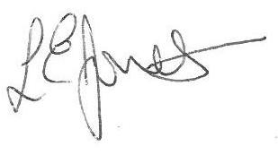
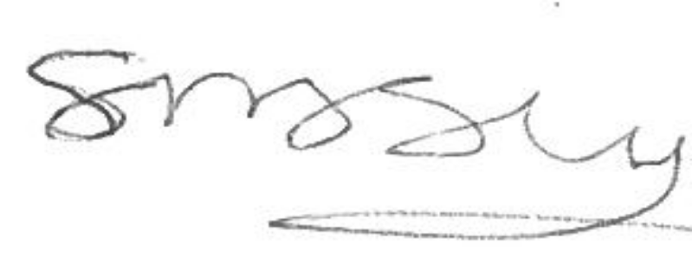

Louise Jones Sean Sly
Executive Head Acting Deputy Head

Royd Nursery Infant School
Carr Road, Deepcar
Sheffield, S36 2PR
Tel 0114 288 2594
Email enquiries@royd.sheffield.sch.uk
www.roydnurseryinfants.co.uk
Headteacher: Louise Jones

Macmillan Coffee Morning – 4 October 2023

Name of Child : Class :

Name of Parent / Carer :

I would like to support on the 4 October 2023 by

Bringing in a cake(s)

Attending the coffee morning

Signed : Parent / Carer

