

Royd Nursery Infant School

Carr Road, Deepcar

Sheffield, S36 2PR

Tel 0114 288 2594

Email [enquiries@royd.sheffield.sch.uk](mailto:enquiries@royd.sheffield.sch.uk)

[www.roydnurseryinfants.co.uk](http://www.roydnurseryinfants.co.uk)

Headteacher: Louise Jones

25 September 2023

Dear Parent/Carers,

On Wednesday 18 October 2023 the photographer will be in school taking individual photographs of the children.

If you have children in 2 year provision, Nursery, School and Deepcar St John Juniors they will be photographed together during the normal school day.

If your child attends the 2 year provision or Nursery and does not attend on a Wednesday and you would like a photograph taken this session will be between 9.00 am and 9.30 am. Please arrive at school for 9.00 am.

You can also include younger brothers and sisters who do not attend nursery in family group sessions if you choose. The family group photograph session will be between 8.30 am and 9.00 am. Please come to the main School reception.

You will receive a proof from the photographer with details of how to place an order. The orders are not be placed via School. Thank you.

Yours sincerely,

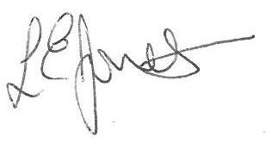

Louise Jones Sean Sly

Executive Head Acting Deputy Head





