

Royd Nursery Infant School

Carr Road, Deepcar

Sheffield, S36 2PR

Tel 0114 288 2594

Email [enquiries@royd.sheffield.sch.uk](mailto:enquiries@royd.sheffield.sch.uk)

[www.roydnurseryinfants.co.uk](http://www.roydnurseryinfants.co.uk)

Headteacher: Louise Jones

30 October 2023

Dear Parent/Carers,

Research has shown that the single most important thing that a parent can do to help their child acquire language, prepare their child for school, and instil a love of learning in their child, is to read with them. Reading helps create a stronger Parent/Child relationship, basic speech skills, the basics of how to read a book, improved communication skills, increased logical thinking skills, exposure to new experiences, enhanced concentration and discipline, and the knowledge that reading is fun to name but a few!

Libraries are an important part of any community. It is an excellent way to engage your child in learning. They hold a wide range of stock including age appropriate books, DVDs, music, newspapers, magazines and free access to computers. Studies have shown that children who use the library are twice as likely to be above average readers.

Reception children will be visiting Stocksbridge Library on Wednesday 29 November 2023. We will be leaving School at 9:00am for the Library session starting at 10:00am and returning at 12:00pm in time for dinner time.

We will be walking there and back so if there are any Parent/Carer volunteers that would like to help walk with the children please could you inform the class teacher. (Please be aware that siblings are unable to join us.) Thank you.

Yours sincerely,

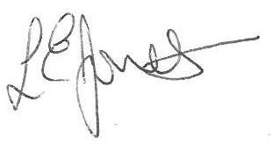



Louise Jones Sean Sly

Executive Head Acting Deputy Head





