

Royd Nursery Infant School

Carr Road, Deepcar

Sheffield, S36 2PR

Tel 0114 288 2594

Email [enquiries@royd.sheffield.sch.uk](mailto:enquiries@royd.sheffield.sch.uk)

[www.roydnurseryinfants.co.uk](http://www.roydnurseryinfants.co.uk)

Headteacher: Louise Jones

10 October 2023

Dear Parent/Carers,

Parents Evening for 2 Year Old, Nursery, Reception, Year 1 and Year 2 will take place on the following dates:

* Wednesday 1 November 2023 3.30 pm to 6.00 pm
* Monday 6 November 2023 3.30 pm to 6.00 pm

Parent/carers will be able to come in to the classroom for their appointment. The procedure will be for parent/carers to arrive outside your child’s classroom door, via the main school gate (unless in Nursery where you will enter via the usual route), two minutes before the appointment time. The teacher will then come out to collect you.

To ensure that everybody has a fair chance of booking an appointment, please complete the form overleaf indicating your preference and return the form by Tuesday 17 October 2023 at the latest and School will endeavour to meet your request. Please note, due to the volume of replies email requests will not be accepted.

Confirmation of appointment times will be sent Friday 20 October 2023 by email. Thank you

Yours sincerely,

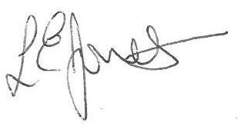

Louise Jones Sean Sly

Executive Head Acting Deputy Head



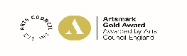



-----------------------------------------------------------------------------------------------------------------------------------------------

**Parents Evening November 2023**

**Name of Child** : Class :

Wednesday 1 November between 3.30 pm and 5.00 pm

Wednesday 1 November between 5.00 pm and 6.00 pm

Monday 6 November between 3.30 pm and 5.00 pm

Monday 6 November between 5.00 pm and 6.00 pm