
`Weekly Newsletter
W.B. 16.10.23

This week:
As part of English the children have analysed their Little Red Riding Hood stories. Children read their own piece of writing and checked whether they had met each step for success (story language, past tense, coordinating conjunction ‘and’, punctuation and ambitious words).

As part of Maths the children have been accurately positioning numbers by looking at the scale (either five frame or ten frame) and counting either forwards or backwards to the box. The children know when the numbers are getting smaller/decreasing, we are counting backwards and when the numbers are getting larger/increasing, we are counting forwards.

Can your child look at the start and end numbers below and identify whether they are counting forwards or backwards and then count either forwards or backwards to the box to work out the missing numbers.

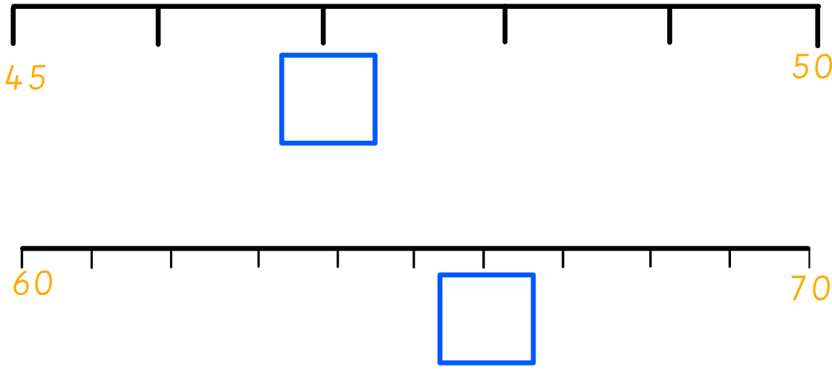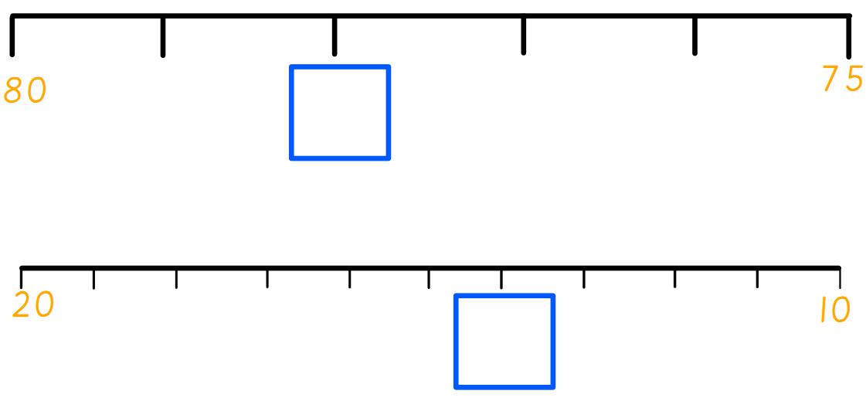

The children have now started their new topic ‘Memory Box’, focusing on the Victorian Era. On Wednesday, children had a ‘Topic Day’ where they completed some History and Art lessons so they had some prior topic knowledge before heading off on their trip to the ‘Old Victorian Classroom’ in Barnsley after the half-term break. In our History lessons, we had lots fun exploring and playing with a range of Victorian toys before sorting pictures of toys into the categories ‘old’ and ‘new’.
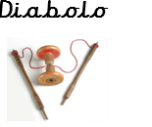

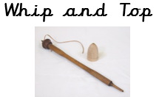
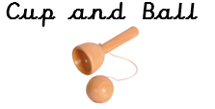

In our Art learning we discussed what we like and dislike about a sketch by Monica Lee and Diego Fazio. After this, we learnt some sketching skills including stippling, circulism, hatching and cross-hatching.

Can your child demonstrate how to do the sketching skill ‘hatching’?

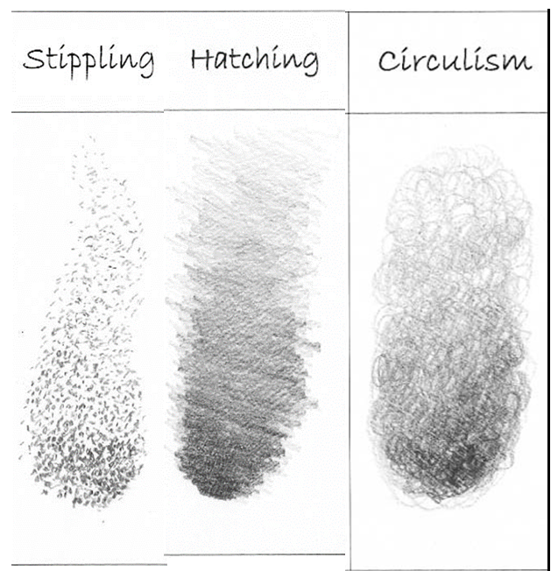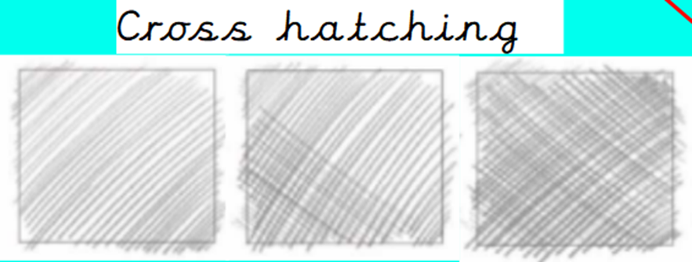

Reminders:
Class 7 PE days are Tuesday and Thursday.
Class 8 PE days are Tuesday and Thursday.
Class 9 PE days are Monday and Wednesday.

Attendance for KS1:
Class 7 – 95.1%
Class 8 – 93%
Class 9 – 98.6%

Homework
Homework will mainly be handed out on a Wednesday. On the odd occasion it may be on a different day due to timetable changes. Please return homework on a Monday. Handing it on a Monday gives you the opportunity before the weekend to ask the teacher any questions so that you are clear of how to support your child if unsure. There is a tray in each class where the homework needs to be returned. Please ask the teacher where this tray is if unsure.

Spellings
Spellings are handed out each Thursday and your child will be tested on these spellings the following Thursday. Children will receive a list of spellings to practise each week. In addition to the spellings, children will be tested on a sentence containing the words. However, the sentence will not be sent home. This is to see if they can apply the spelling currently within their writing. Can you get your child to practise applying the words by creating their very own sentences?

Reading Diaries
Children in KS1 have all been provided with a Home Reading Diary. Please fill this in daily based on your child reading a couple of pages of a book or a whole book. Please return the Reading Diary to school each day and leave it in the designated classroom tray. There are books situated in the classroom for your child to take home daily. Reading is extremely important to your child’s development so we really encourage your child to read a book or pages of a book daily. If you are unsure of your child’s reading book colour then please ask your teacher.

Thank you
Miss Rawding, Miss Bamford & Miss Payne

