2 Year Provision Newsletter
– w/c 02/10/23
Last week
In 2 year provision last week we began doing activities around our theme ‘Why do you love me so much! This is a lovely topic as it’s around ‘All about me’ so we get an opportunity to find out a bit more about the little ones in our provision.

Our adult led craft was around doing self-portraits. They really enjoyed looking at their faces and features in the mirror and using these images to make their very own portraits. We have very proudly displayed some of these on our wall as they are so amazing!

Our Song of the week was ‘Head, Shoulders, knees and toes’ in keeping with the parts of the body theme.

Next week  This week we are continuing our theme ‘Why do you love me so much’. So, we are still learning ‘all about me’ and looking at who lives in our house.  This links in nicely to our book of the week ‘Owl Babies’. We will be doing various activities linked to this book. | Book of the week  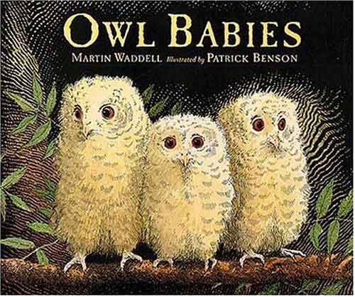  This Photo by Unknown Author is licensed under CC BY-SA  This story is linked to our theme we are running this term. Maybe if you have this story at home you could look though the story together at bedtime.  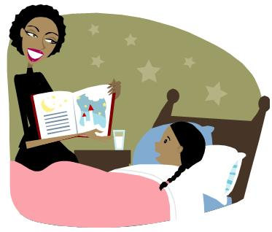  This Photo by Unknown Author is licensed under CC BY-SA-NC
Dates for your diary
Macmillan Stay and Play – Wednesday 4thOctober 2023
Individual class photos – Wednesday 18th October 2023
Curriculum Day - Friday 20th October 2023
Half Term - Monday 23rd October to Friday 27th October2023
We return to school on Monday 30th October 2023
Reminder
Please remember to ensure all your child’s clothing and water bottles are labelled and if you could provide spare clothes in their bag as we are very low on spare clothes.
Thank you!

Now the weather is turning a bit cooler can you please ensure your child brings a warm coat, hat and gloves. We will be playing out in all weathers so if you would like to provide them with some wellingtons in a labelled carrier bags as we have some large puddles which develop when it rains heavy and children love to jump in muddy puddles!

