2 Year Provision Newsletter
– w/c 16/10/23
Last week
We have continued doing activities around our theme ‘Why do you love me so much!
Our adult led craft was around our shared read which is owl babies, the children have been making owls using different shapes.

This theme has been carried on through the provision so we have had plenty of opportunities to talk about the story in more detail.
Our Song of the week was ‘Head, Shoulders, knees and toes’ and ‘Wind the bobbin up’.

This Week.  This week we are continuing our theme around our topic and our shared read.  Wednesday18th are Individual Class Photos  Don’t forget Friday is a curriculum day so the last day of this term is Thursday 19th October 2023  Next week is half term, so we hope you have a lovely break! | Book of the week  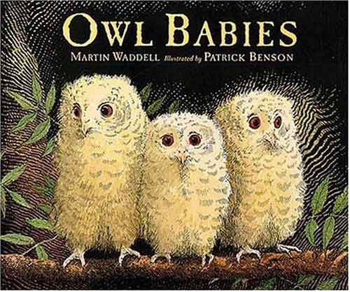  This Photo by Unknown Author is licensed under CC BY-SA  This story is linked to our theme we are running this term. Maybe if you have this story at home you could look though the story together at bedtime.  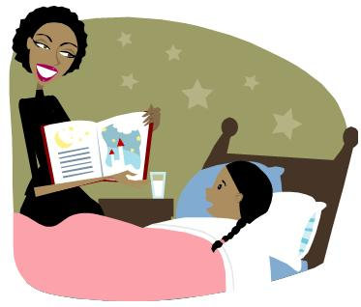  This Photo by Unknown Author is licensed under CC BY-SA-NC
Dates for your diary
Individual class photos – Wednesday 18th October 2023
Curriculum Day - Friday 20th October 2023
Half Term - Monday 23rd October to Friday 27th October2023
We return to school on Monday 30th October 2023
Reminder
Please remember to ensure all your child’s clothing and water bottles are labelled and if you could provide spare clothes in their bag as we are very low on spare clothes.
Thank you!

Now the weather is turning a bit cooler can you please ensure your child brings a warm coat, hat and gloves. We will be playing out in all weathers so if you would like to provide them with some wellingtons in a labelled carrier bags as we have some large puddles which develop when it rains heavy and children love to jump in muddy puddles!

