2 Year Provision Newsletter – w/c 18/09/23
Last week
Welcome back after the summer break and a warm welcome to all our new starters!!

In 2 year provision last week we were settling in and getting to know our new children who have joined us this term.
This can be an upsetting time for both you and your child, as this could be the first time some of your children have attended an early year setting, for some this may take a little longer while they secure new relationships with staff. Please let us know if you require any additional support during this period.
We feel they have done absolutely amazing!

This week  This week we are beginning our theme ‘Why do you love me so much’. We will be doing activities around ‘all about me’ this gives us the opportunity to get to know your little ones a little better, finding out who lives in their house, which people are special to them! | Book of the week  This story is linked to our theme we are running this week. Maybe if you have this story at home you could look though the story together at bedtime.
Dates for your diary
Macmillan Stay and Play – Wednesday 4thOctober2023
Individual class photos – Wednesday 18th October
Friday 20th October – Curriculum Day

Reminder
Please remember to ensure all your child’s clothing and water bottles are labelled and if you could provide spare clothes in their bag as we are very low on spare clothes.

Now the weather is turning a bit cooler can you please ensure your child brings a warm coat, hat and gloves. We will be playing out in all weathers so if you would like to provide them with some wellingtons in a labelled carrier bags as we have some large puddles which develop when it rains heavy and children love to jump in muddy puddles!

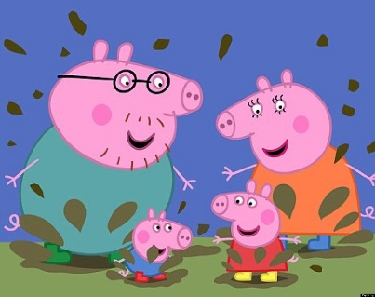
This Photo by Unknown Author is licensed under CC BY-NC-ND
This Photo by Unknown Author is licensed under CC BY-NC-ND

