

Royd Nursery Infant School

Carr Road, Deepcar

Sheffield, S36 2PR

Tel 0114 288 2594

Email [enquiries@royd.sheffield.sch.uk](mailto:enquiries@royd.sheffield.sch.uk)

[www.roydnurseryinfants.co.uk](http://www.roydnurseryinfants.co.uk)

Headteacher: Louise Jones

6 November 2023

Dear Parents and Carers,

From the week commencing 13 November 2023 until the end of the Autumn term, Miss Bamford will be working Monday, Tuesday and Wednesday with Mrs Musgrave working Thursday and Friday.

Mrs Musgrave is a vastly experienced teacher and has extensive knowledge of whole school routines. She has worked at Royd for a considerable number of years and has a strong teaching and learning track record.

Thank you for your continued support.

Yours sincerely,

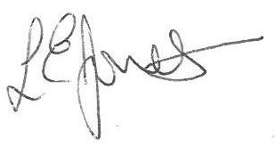

Louise Jones Sean Sly

Executive Head Acting Deputy Head





