

Royd Nursery Infant School

Carr Road, Deepcar

Sheffield, S36 2PR

Tel 0114 288 2594

Email [enquiries@royd.sheffield.sch.uk](mailto:enquiries@royd.sheffield.sch.uk)

[www.roydnurseryinfants.co.uk](http://www.roydnurseryinfants.co.uk)

Headteacher: Louise Jones

14 November 2024

Dear Parents/Carers

We would like to invite you in to School for a Stay and Play session with your child on Wednesday 20 December 2023.

There will be a carousel of festive activities for you and your child to join in with. The sessions will be from 9:00 am until 9.45 am or 2.15 pm until 3pm. If your child does not attend provision on this day they are welcome to join in however, a parent/carer must stay with your child due to ratio’s.

Please complete and return the slip below or email Mrs Stuart [pstuart@royd.sheffield.sch.uk](mailto:pstuart@royd.sheffield.sch.uk) if you would like to join us. It would be lovely to see you all.

Yours sincerely,

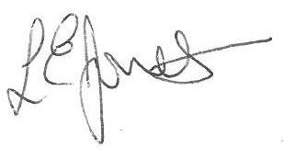

Louise Jones Sean Sly

Executive Head Acting Deputy Head

_____________________________________________________________________

**2 Year Provision Stay and Play December 2023**

Name of child: Class:

Yes I / We would like to join you for the Stay and Play

Please select either 9am – 9.45 am **OR** 2.15 pm – 3.00 pm

No I / We are unable to attend.

Signed ____________________________________________________ Parent/carer





