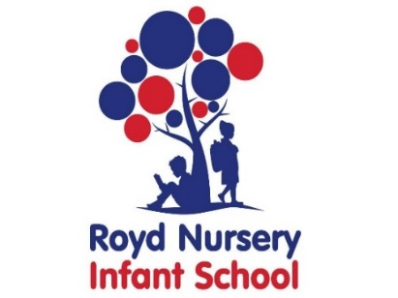

Royd Nursery Infant School

Carr Road, Deepcar

Sheffield, S36 2PR

Tel 0114 288 2594

Email [enquiries@royd.sheffield.sch.uk](mailto:enquiries@royd.sheffield.sch.uk)

[www.roydnurseryinfants.co.uk](http://www.roydnurseryinfants.co.uk)

Headteacher: Louise Jones

15 November 2023

Dear Parent/Carers,

The Christmas concerts for the Foundation children (Nursery and Reception) will be on Tuesday 19 December 2023 and Thursday 21 December 2023 at 10 am. Performances will take place in the main school hall. Younger siblings are welcome to attend but please be aware they will sit on your knee and not have a separate seat. May we kindly request that should siblings begin to make a noise please take them down to the school office so children in the play are not distracted.

Entry to the show is free and we would really appreciate your support by purchasing raffle tickets on the day to help raise money for the School. If you have any items that you would like to donate for the raffle prizes please leave them in the School Office. Thank you.

Photographs are not allowed during the event. Individual photographs will be taken during dress rehearsal and sent home to parents/carers.

If you would like to attend please complete and return the attached form with the number of tickets requested. Please DO NOT email your request. Tickets are allocated on a first come first served basis. We will endeavour to accommodate all ticket requests however, please be aware that we have limited space.

We look forward to seeing you.

Yours sincerely,

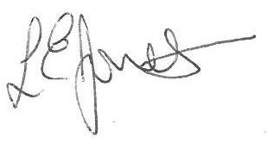

Louise Jones Sean Sly

Executive Head Acting Deputy Head



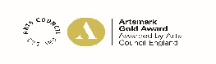

Royd Nursery Infant School

Carr Road, Deepcar

Sheffield, S36 2PR

Tel 0114 288 2594

Email [enquiries@royd.sheffield.sch.uk](mailto:enquiries@royd.sheffield.sch.uk)

[www.roydnurseryinfants.co.uk](http://www.roydnurseryinfants.co.uk)

Headteacher: Louise Jones



**Nursery and Reception Christmas Concerts 2023**

Child’s Name : Class :

1. **Please request number of tickets.**

Tickets for 10 am performance on Tuesday 19 December

Tickets for 10 am performance on Thursday 21 December.

Please return to the school office. Tickets will be allocated on a first come first served basis. Thank you.