

Royd Nursery Infant School

Carr Road, Deepcar

Sheffield, S36 2PR

Tel 0114 288 2594

Email [enquiries@royd.sheffield.sch.uk](mailto:enquiries@royd.sheffield.sch.uk)

[www.roydnurseryinfants.co.uk](http://www.roydnurseryinfants.co.uk)

Headteacher: Louise Jones

3 November 2023

Dear Parents and Carers,

We are selling poppies and other items for the British Legion Poppy Appeal.

If you would like to buy an item please bring the money into school on Tuesday 7th November 2023.

As well as selling traditional poppies we are also selling the following items:

Snap bands - £1.50

Poppy reflector - 50p

Zip pull – 50p

Silicon wristband - £1

You are also very welcome to donate more than the suggested price. Thank you, in advance, for all your support to this worthwhile cause.

Yours sincerely,

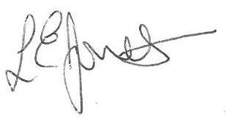

Louise Jones Sean Sly

Executive Head Acting Deputy Head





