
Weekly Newsletter
W.B. 6.11.23

This week:
As part of English this week the children have started their first poetry genre, focusing on the poem ‘Teddy’. First, the children had to create their own actions for different lines in the poem. After practising each line of the poem with their chosen actions, the children performed to each other. In the next lesson, we analysed key elements of a poem looking at the two stanzas (a group of lines) in our poem and the lines (there are eight lines in our poem, four in each stanza). Now that the children could perform and analyse the poem, they were ready to reorder it. The children were given the poem chopped up into pieces containing two lines at a time and had to work out the correct order to place them in. The children loved reading the poem aloud whilst they were doing this activity to remind them which line should come next.

Can your child tell you what a stanza is?

As part of Maths the children have been learning to count in 10’s forwards and backwards. The children know that when we count in
10’s the numbers end in a 0.

Can your child complete the counting sequences below by filling in the missing numbers? Remember to check whether the sequences are counting forwards or backwards first!

30, 40, ____, 60, 70, ___, ___
100, ___, 80, 70, ___, ____, 40

The children’s topic this half term is ‘Memory Box’. In our Science lessons this week, children have learnt the names of the different animal groups based on what they eat – herbivores (eat plants), carnivores (eat meat) and omnivores (eat both plants and meat). The children then sorted a group of animals into the correct columns on their grid.
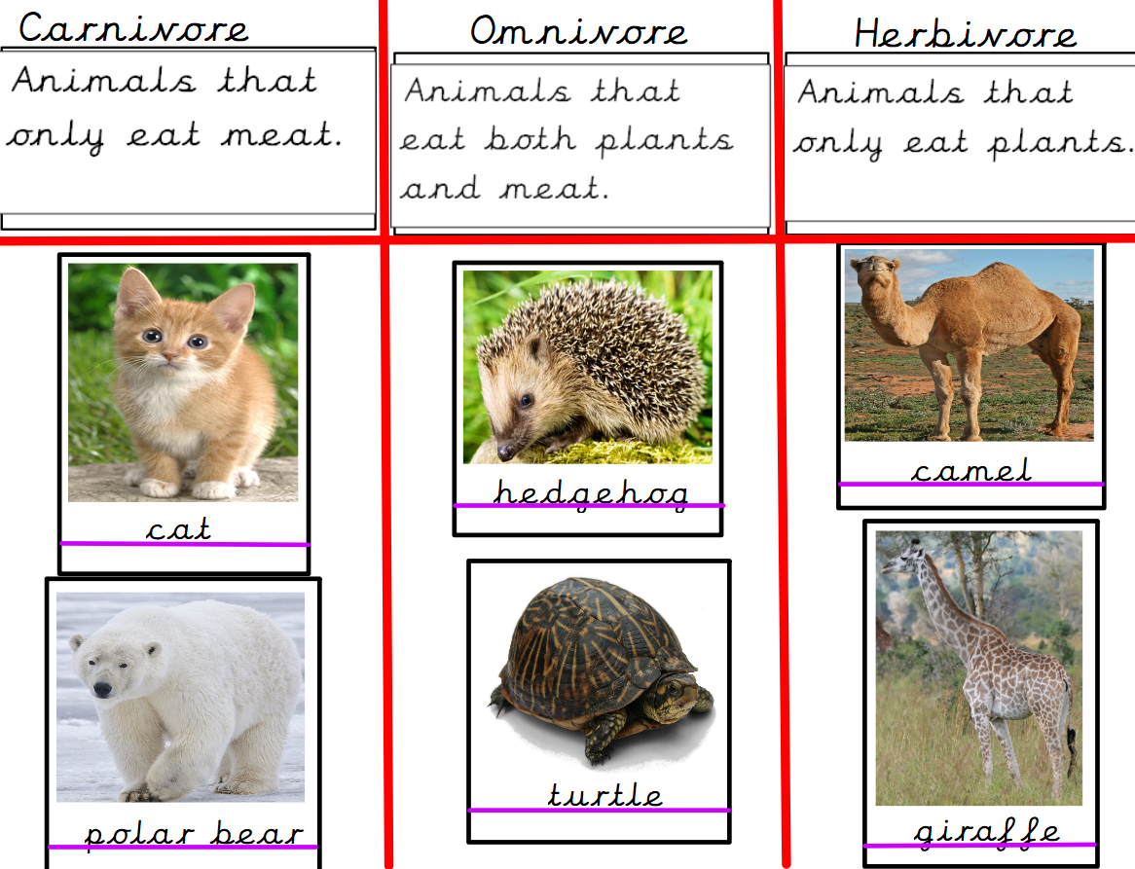

Can your child name the different groups and say what they eat? What is a lion (herbivore, carnivore or omnivore)? What is a human (herbivore, carnivore or omnivore)? What is a sheep (herbivore, carnivore or omnivore)?

Reminders:
Class 8 PE days are Tuesday and Thursday.
Class 9 PE days are Monday and Wednesday.

Attendance for KS1:
Class 8 – 96.9%
Class 9 – 95.6%

Homework
Homework will mainly be handed out on a Wednesday. On the odd occasion it may be on a different day due to timetable changes. Please return homework on a Monday. Handing it on a Monday gives you the opportunity before the weekend to ask the teacher any questions so that you are clear of how to support your child if unsure. There is a tray in each class where the homework needs to be returned. Please ask the teacher where this tray is if unsure.

Spellings
Spellings are handed out each Thursday and your child will be tested on these spellings the following Thursday. Children will receive a list of spellings to practise each week. In addition to the spellings, children will be tested on a sentence containing the words. However, the sentence will not be sent home. This is to see if they can apply the spelling currently within their writing. Can you get your child to practise applying the words by creating their very own sentences?

Reading Diaries
Children in KS1 have all been provided with a Home Reading Diary. Please fill this in daily based on your child reading a couple of pages of a book or a whole book. Please return the Reading Diary to school each day and leave it in the designated classroom tray. There are books situated in the classroom for your child to take home daily. Reading is extremely important to your child’s development so we really encourage your child to read a book or pages of a book daily. If you are unsure of your child’s reading book colour then please ask your teacher.

Both Reception classes are short of pink band reading books. If you still have any at home from when your child was in Reception, please can you return these to your child's class teacher who will pass them onto Reception staff. Thank you.

Thank you
Miss Rawding & Miss Payne

