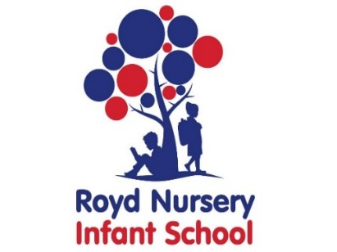

Royd Nursery Infant School

Carr Road, Deepcar

Sheffield, S36 2PR

Tel 0114 288 2594

Email [enquiries@royd.sheffield.sch.uk](mailto:enquiries@royd.sheffield.sch.uk)

[www.roydnurseryinfants.co.uk](http://www.roydnurseryinfants.co.uk)

Headteacher: Louise Jones

13 September 2023

Dear Parents/Carers

**Whirlow Residential 2024**

We are delighted to offer Year 2 children the opportunity to attend the Whirlow residential in 2024!

We have offered this experience for many years and each visit has been exciting and fun giving children strong learning experiences of independence, getting on with others, seeing life on a farm and enjoying countryside activities. Views of parents/carers from previous visits have been that although they were anxious initially, were thrilled upon the children’s return at how much they had enjoyed themselves and amazed at how independent the children had become in such a short time.

The visit for each child will be for 2 days and 1 night during the period of Wednesday 19 June 2024 and Friday 21 June 2024. The cost will be £52 per pupil. This covers transport there and back, accommodation, catering and farm activities. The children also go on a short local walk.

If you would like your child to go on the residential please complete and return the consent form to Mrs Stuart in the Office as soon as possible. Payment is via Parentpay and can be made in instalments if you wish. However full payment needs to be received by Thursday 29 February 2024. Thank you.

Yours sincerely,

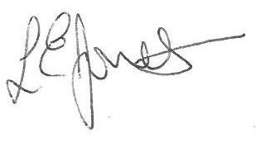

Louise Jones Sean Sly

Executive Head Acting Deputy Head



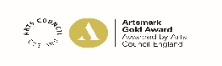



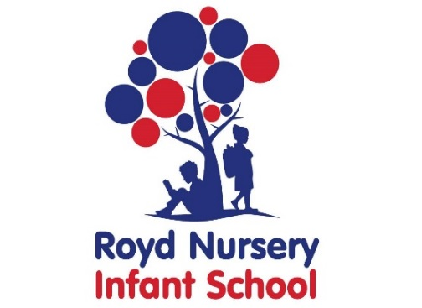

**Year 2 Whirlow Farm Residential 2024**

Child’s name : Class :

I/We would like my child to go to Whirlow Hall Farm for the residential visit during the period of Wednesday 19 June 2024 and Friday 21 June 2024 for 2 days and 1 night.

The payment of £52 has been made via Parentpay.

The payment of £52 will be in instalments via Parentpay by Thursday 29 February 2024

***I also understand that by signing this form I am providing consent for Whirlow Hall Farm to possibly use photograph’s of my child in publicity brochures.***

No, I/We do not wish for my/our child to go on the residential visit.

Signed : ___________________________________________ Parent/Carer

Date : ____________

