2 Year Provision Newsletter – w/c 06/11/23
Last week
Welcome back after the half term break, we hope you had a lovey week.

Last week in our 2 year provision we have been learning about our new topic “ What Makes A Shadow” we have various resources in provsion to spark conversations around this.

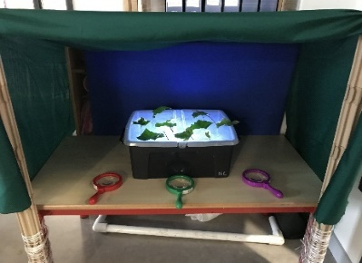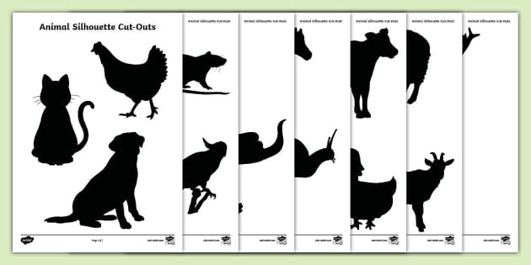

We have also started our Arts week craft which will run over the next two week. Our children have enjoyed creating craft around our book Owl Babies.

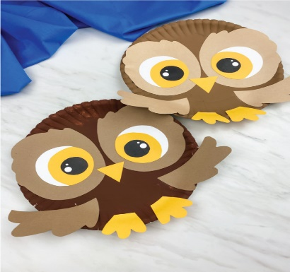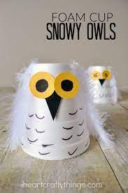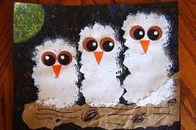
This week  We are continuing with our topic as well as our craft for Arts week.  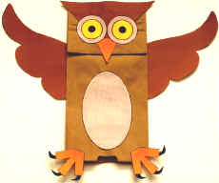 | Book of the week  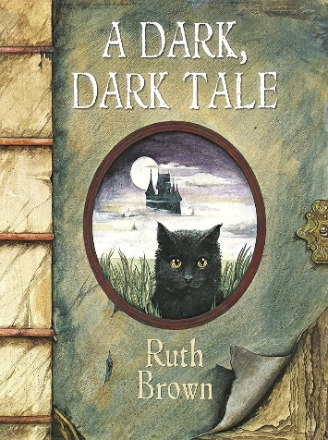  This story is linked to our theme we are running this week. Maybe if you have this story at home you could look though the story together at bedtime.
Dates for your diary
Remembrance Day 11th November
Children in Need- Friday 17th November

Reminder
Please remember to ensure all your child’s clothing and water bottles are labelled and if you could provide spare clothes in their bag as we are very low on spare clothes.

Now the weather is turning a bit cooler can you please ensure your child brings a warm coat, hat and gloves. We will be playing out in all weathers so if you would like to provide them with some wellingtons in a labelled carrier bags as we have some large puddles which develop when it rains heavy and children love to jump in muddy puddles!

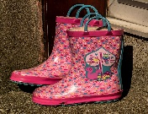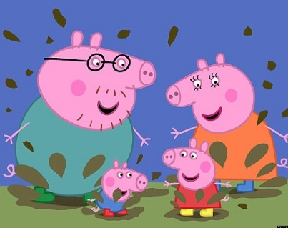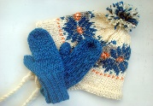
This Photo by Unknown Author is licensed under CC BY-NC-ND
This Photo by Unknown Author is licensed under CC BY-NC-ND

