2 Year Provision Newsletter – w/c 20/11/23
Last week

Last week in our 2 year provision we have been learning about our new topic “ What Makes A Shadow” we have various resources in provsion to spark conversations around this.

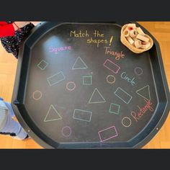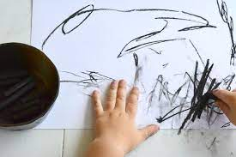

We also finished off our Arts week craft which will be displayed in the 2 year provision over the coming weeks. Our children have enjoyed creating craft around our book The Owl Babies.

Children in Need
Children enjoyed dressing up and doing various activities for Children in Need – lots of fun was had by all!
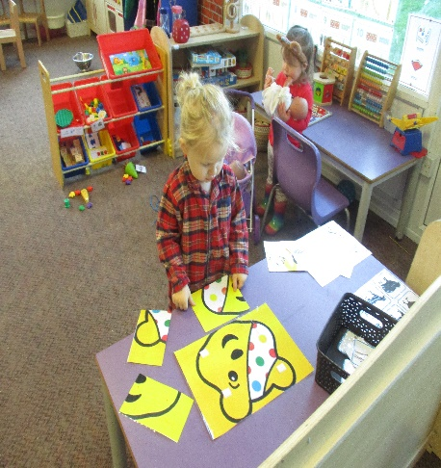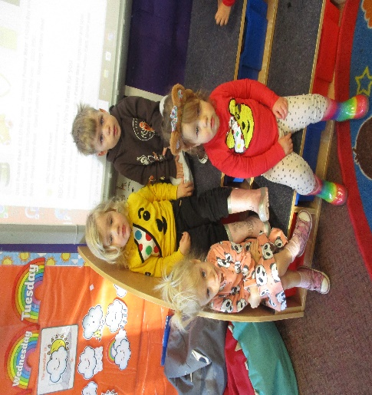

This week  This week we are continuing our theme around our topic.  We will over the coming weeks be moving our attention to Christmas themed craft and activities. | Book of the week  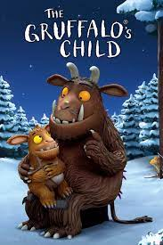  This story is linked to our theme we are running this week. Maybe if you have this story at home you could look though the story together at bedtime.
Dates for your diary
Wednesday 20th December – Christmas Stay and Play
Friday 22nd December – last Day

Reminder
Please remember to ensure all your child’s clothing and water bottles are labelled and if you could provide spare clothes in their bag as we are very low on spare clothes.

Please ensure your child brings a warm coat, hat and gloves. We will be playing out in all weathers so if you would like to provide them with some wellingtons in a labelled carrier bags as we have some large puddles which develop when it rains heavy and children love to jump in muddy puddles!

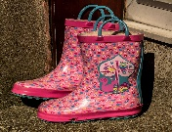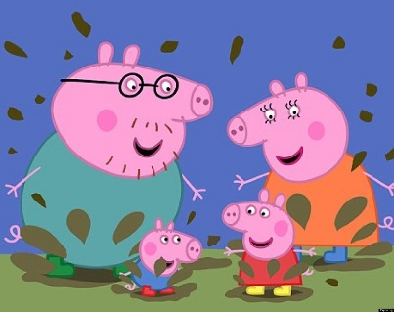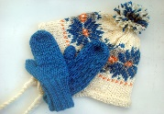
This Photo by Unknown Author is licensed under CC BY-NC-ND
This Photo by Unknown Author is licensed under CC BY-NC-ND

