
Weekly Newsletter
W.B. 27.11.23

This week:
As part of English this week the children have continued with their writing genre; information text. Children wrote some more compound sentences using the subordinating conjunctions ‘when’, ‘if’, ‘because’. Children know that subordinating conjunctions can either go at the start of a sentence or in the middle. For example Because the Jacob’s Ladder is a visual illusion, it looks like the blocks are falling down – It looks like the blocks are falling down because the Jacob’s Ladder is a visual illusion. The children were then ready to start planning their own information text by writing key bullet points for four paragraphs and choosing which Victorian toys they’d like to write about. The children were extremely creative in the next two lessons when producing their very own information text! They remembered all of the key elements including, heading, subheading, paragraphs and technical words to do with the subject. They also remembered their capital letters, full stops and even used ambitious words!

Can your child tell you an interesting fact about the Victorian toy they wrote about?
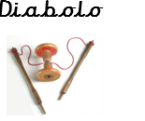
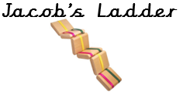
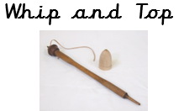
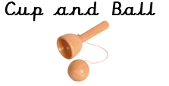

In Maths this week the children have looked at symmetry in 2D and 3D shapes. The children have had to find lines of symmetry making sure that both sides of the shape are equal on both sides. Children have shown their understanding of symmetry in a variety of ways using numicon shapes and numicon peg boards. The children have done using a vertical, horizonal and diagonal line of symmetry and rotational symmetry.

Can your child find lines of symmetry in a 2D shape?
Can your child show you a symmetrical pattern using a diagonal line?

The children’s topic this half term is ‘Memory Box’. In our Design and Technology learning we have focused on practising our cutting; a very important skill! The children learned the correct way to hold the scissors before applying these skills to cut a range of lines and shapes. In our next lesson, we learned about joining techniques. The children loved exploring using techniques such as ‘flange’, ‘slot’ and ‘tabs’ to prepare them for designing and creating their very own Ferris wheel!

Can your child demonstrate how to correctly cut a range of materials?
Can your child tell you which techniques they used to accurately join their materials?

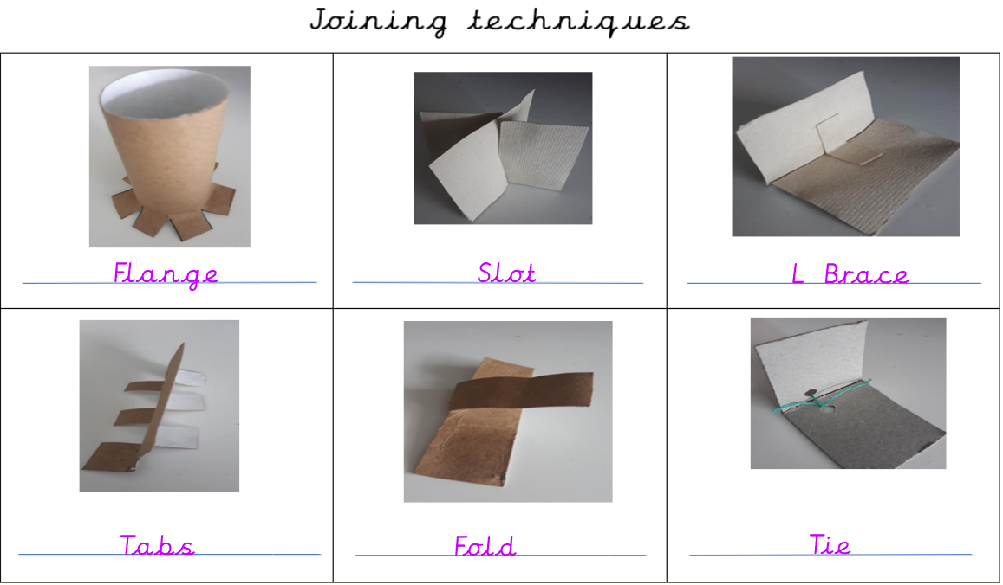

Reminders:
Class 7 PE days are Tuesday and Thursday.
Class 8 PE days are Tuesday and Thursday.

Attendance for KS1:
Class 7 – %
Class 8 – %
Homework
Homework will mainly be handed out on a Wednesday. On the odd occasion it may be on a different day due to timetable changes. Please return homework on a Monday. Handing it on a Monday gives you the opportunity before the weekend to ask the teacher any questions so that you are clear of how to support your child if unsure. There is a tray in each class where the homework needs to be returned. Please ask the teacher where this tray is if unsure.

Spellings
Spellings are handed out each Thursday and your child will be tested on these spellings the following Thursday. Children will receive a list of spellings to practise each week. In addition to the spellings, children will be tested on a sentence containing the words. However, the sentence will not be sent home. This is to see if they can apply the spelling currently within their writing. Can you get your child to practise applying the words by creating their very own sentences?

Reading Diaries
Children in KS1 have all been provided with a Home Reading Diary. Please fill this in daily based on your child reading a couple of pages of a book or a whole book. Please return the Reading Diary to school each day and leave it in the designated classroom tray. There are books situated in the classroom for your child to take home daily. Reading is extremely important to your child’s development so we really encourage your child to read a book or pages of a book daily. If you are unsure of your child’s reading book colour then please ask your teacher.

Thank you
Miss Rawding & Miss Payne

