2 Year Provision Newsletter – w/c 04/12/23
Last week

Last week in our 2 year provision we continued learning about our topic “ What Makes A Shadow” we have various resources in provsion around this.
The children have relly enjoyed learning about this and having fun using different parts of their bodies and objects to create shadows.

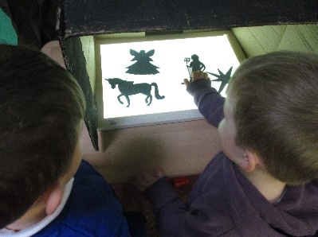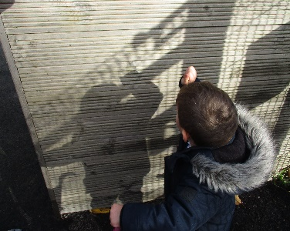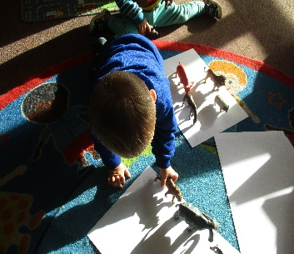

This week  This week we are  moving our attention to Christmas themed craft and activities. Children will be engaging in various craft activities.  We also have various Christmas themed resources, such as Santa’s workshop, an area for the children to write letters to Santa and a Christmas themed small world area. | Book of the week  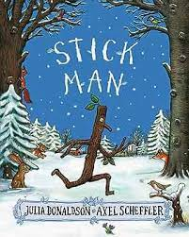  This story is linked to our theme we are running this week. Maybe if you have this story at home you could look though the story together at bedtime.  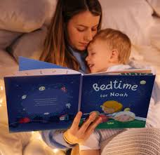
Dates for your diary
Tuesday 19th December – Christmas Party pm
Wednesday 20th December – Christmas Stay and Play
Thursday 21st December – Christmas Party pm
Friday 22nd December – Christmas Jumper Day pay £1 - last Day

School Returns Monday 8th January 2024

Reminder
Please remember to ensure all your child’s clothing and water bottles are labelled and if you could provide spare clothes in their bag as we are very low on spare clothes.

Please ensure your child brings a warm coat, hat and gloves. We will be playing out in all weathers so if you would like to provide them with some wellingtons in a labelled carrier bags as we have some large puddles which develop when it rains heavy and children love to jump in muddy puddles!

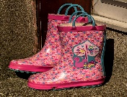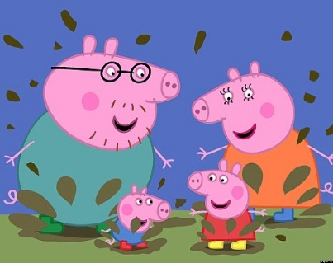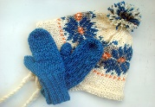
This Photo by Unknown Author is licensed under CC BY-NC-ND
This Photo by Unknown Author is licensed under CC BY-NC-ND

