

Royd Nursery Infant School

Carr Road, Deepcar

Sheffield, S36 2PR

Tel 0114 288 2594

Email [enquiries@royd.sheffield.sch.uk](mailto:enquiries@royd.sheffield.sch.uk)

[www.roydnurseryinfants.co.uk](http://www.roydnurseryinfants.co.uk)

Headteacher: Louise Jones

12 January 2024

Dear Parents / Carers

We would like to invite you in to School for a Stay and Play session with your child on

* Tuesday 30th January 2024 OR
* Wednesday 31st January 2024

There will be a carousel of activities celebrating Chinese New Year and the session will be from 2:15 pm until 3:00 pm.

Should your child not attend provision on Tuesday or Wednesday, parents/carers are welcome to join either session and school must be notified of the date you wish to attend. Your child must be accompanied by an adult due to ratio’s.

Please complete and return the slip below or email [enquiries@royd.sheffield.sch.uk](mailto:enquiries@royd.sheffield.sch.uk) if you would like to join us. It would be lovely to see you all.

Yours sincerely,

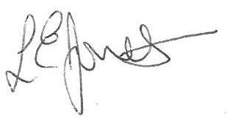

Louise Jones Sean Sly

Executive Head Acting Deputy Head

**2 Year Provision Stay and Play January 2024**

Name of child : Class:

Yes I / We would like to join you for the Stay and Play

Please select either 30th January **OR** 31st January

No I / We are unable to attend.

Signed ____________________________________________________ Parent/carer



