

Royd Nursery Infant School

Carr Road, Deepcar

Sheffield, S36 2PR

Tel 0114 288 2594

Email [enquiries@royd.sheffield.sch.uk](mailto:enquiries@royd.sheffield.sch.uk)

[www.roydnurseryinfants.co.uk](http://www.roydnurseryinfants.co.uk)

Headteacher: Louise Jones

24 November 2023

Dear Parents/Carers

For children in FS2, Y1 and Y2 we are running several extra curricular activities during the Spring 1 half term.

Learn Different Sports is a new one this term and includes tennis, cricket, rugby, hockey and basketball. We also have Dodgeball on a Friday.

For your child to attend, you will need to log on to Parentpay then select and pay for the club/s you wish your child to attend. This will be on a first come first served basis and the places become available later today.

Thank you.

Yours sincerely,

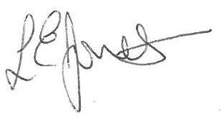

Louise Jones Sean Sly

Executive Head Acting Deputy Head

-------------------------------------------------------------------------------------------------------------------  
**Extra Curricular Activities spring 1 2024**

**Monday**

Learn Different Sports FS2/Y1/Y2 3.20pm – 4.20 pm 8 Jan – 5 Feb £20

**Tuesday**

Dance FS2/Y1/Y2 3.20pm – 4.20pm 9 Jan – 6 Feb £20

**Wednesday**

Football Y1//Y2 3.30pm – 4.30pm 10 Jan – 7 Feb £20

**Friday**

Dodgeball FS2/Y1/Y2 3.20pm – 4.20 pm 12 Jan – 9 Feb £20



