

Royd Nursery Infant School

Carr Road, Deepcar

Sheffield, S36 2PR

Tel 0114 288 2594

Email [enquiries@royd.sheffield.sch.uk](mailto:enquiries@royd.sheffield.sch.uk)

[www.roydnurseryinfants.co.uk](http://www.roydnurseryinfants.co.uk)

Headteacher: Louise Jones

12 January 2024

Dear Parents / Carers of

We would like to invite you in to School for a Stay and Play session with your child

* Thursday 1st February 2024 OR
* Tuesday 6th February 2024

There will be a carousel of activities celebrating Chinese New Year and the session will be from 2:15 pm until 3:00 pm.

Should your child not attend provision on Thursday or Tuesday, parents/carers are welcome to join either session and school must be notified of the date you wish to attend. Your child must be accompanied by an adult due to ratio’s.

Please complete and return the slip below or email [enquiries@royd.sheffield.sch.uk](mailto:enquiries@royd.sheffield.sch.uk) if you would like to join us. It would be lovely to see you all.

Yours sincerely,

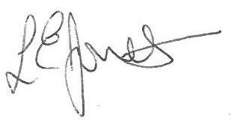

Louise Jones Sean Sly

Executive Head Acting Deputy Head

**Nursery Stay and Play February 2024**

Name of child **:**  Class:

Yes I / We would like to join you for the Stay and Play

Please select either 1st February **OR** 6th February

No I / We are unable to attend.

Signed ____________________________________________________ Parent/carer



