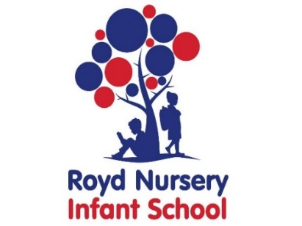

Royd Nursery Infant School

Carr Road, Deepcar

Sheffield, S36 2PR

Tel 0114 288 2594

Email [enquiries@royd.sheffield.sch.uk](mailto:enquiries@royd.sheffield.sch.uk)

[www.roydnurseryinfants.co.uk](http://www.roydnurseryinfants.co.uk)

Headteacher: Louise Jones

4 December 2023

Dear Parent/Carers,

Our topic in Year 1 and 2 will be ‘Rio di Vida’ and we have arranged for Music Specialists from the Sheffield Music Hub to work with the children on Brazilian music.

The event will be on Friday 19 January 2023 and the contribution is £6.50 per child.

If you would like your child to take part contribution and consent is via Parentpay. Please complete this by Monday 8 January 2024. If there are any issues please do not hesitate to contact Mr Sly.

Thank you.

Yours sincerely,



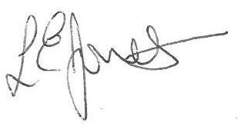

Louise Jones Sean Sly

Executive Head Acting Deputy Head



