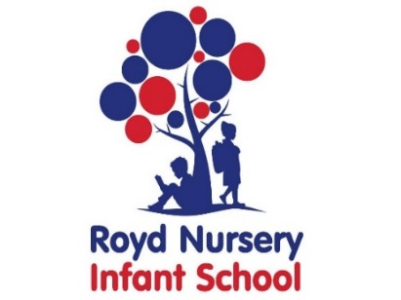

Royd Nursery Infant School

Carr Road, Deepcar

Sheffield, S36 2PR

Tel 0114 288 2594

Email [enquiries@royd.sheffield.sch.uk](mailto:enquiries@royd.sheffield.sch.uk)

[www.roydnurseryinfants.co.uk](http://www.roydnurseryinfants.co.uk)

Headteacher: Louise Jones

9 October 2023

Dear Parents/Carers

We have booked to take our Year 1 and Year 2 children to the ‘Victorian Classroom Barnsley’ in October/November. The visit will promote a better understanding of life in the Victorian era and what life was like for children in Victorian times. The trip for Class 9 will be on Thursday 2 November 2023.

Upon arrival children and adults will be asked to dress up in an outfit that is provided for us. However, if you would like to source your own outfit of flat caps and waistcoats for boys, white pinafores and mop caps for girls then that is fine too.

**Important**

It will be a full day visit and you will need to provide your child with their water bottle and a plain packed Victorian lunch of bread, cheese, pastie wrapped in a tea towel or brown paper. Obviously, if your child has special dietary requirements please provide what your child will need to eat.

The coach will leave School at 9.00 am prompt therefore children must be in class and ready for registration by 8.50 am at the latest. The children will be back by 3.15 pm. The contribution is £24.50 per child.

If you would like your child to attend, contribution and onsnt is by Parentpay. Please complete this by Monday 30 October 2023. If there are any issues please do not hesitate to contact Mr Sly. Thank you.

Yours sincerely,

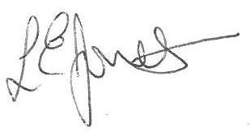

Louise Jones Sean Sly

Executive Head Acting Deputy Head



