
Weekly Newsletter
W.B. 15.1.24

Please can we ask that any reading books taken home are returned to your child’s classroom book boxes after they’ve been used.

This week:

As part of English this week we have continued our second cycle of story writing. We have focused on writing different types of sentences including questions and exclamation sentences. A question is when we want a response or an answer from someone and we always end it with a question mark ‘?’ We came up with a range of question words we can use to start a question when we are writing including; who, what, where, why, when, how, do, which, can, is, are, were. Whenever we are writing an exclamation sentence it must include strong feeling or emotion and end with an exclamation mark ‘!’ For example, “You look horrendous!” screamed Tom.



As part of Maths this week the children have continued to look at capacity and volume. The children were given a volume measurement and they used their knowledge of counting in 1s, 2s, 3s, 5s and 10s to figure out what the scale was going up in so they could work out what the missing numbers were. From this they could then draw the given volume measurement on to the scale. The children also enjoyed being mathematicians to figure out word problems related to volume and capacity and they thoroughly enjoyed an investigation of planning their very own magic portion. The children had to pick 6 ingredients which could not go over the total capacity of 100ml so they had to think really carefully about the volume of each ingredient.

Can your child tell you what capacity and volume mean?
Can your child find different containers at home and figure out what the scales are counting in?

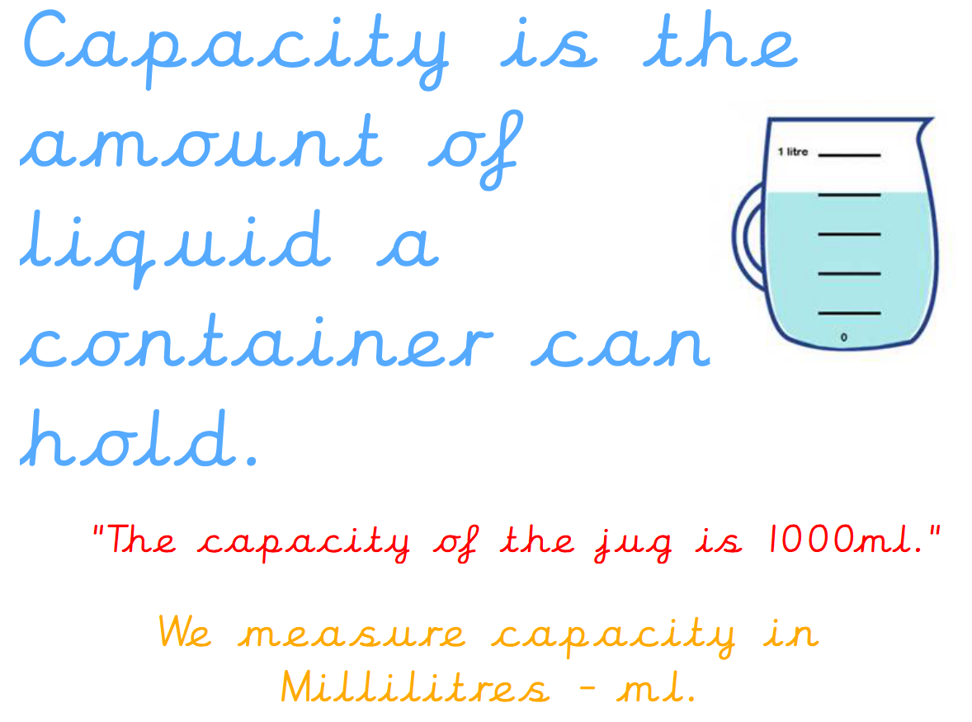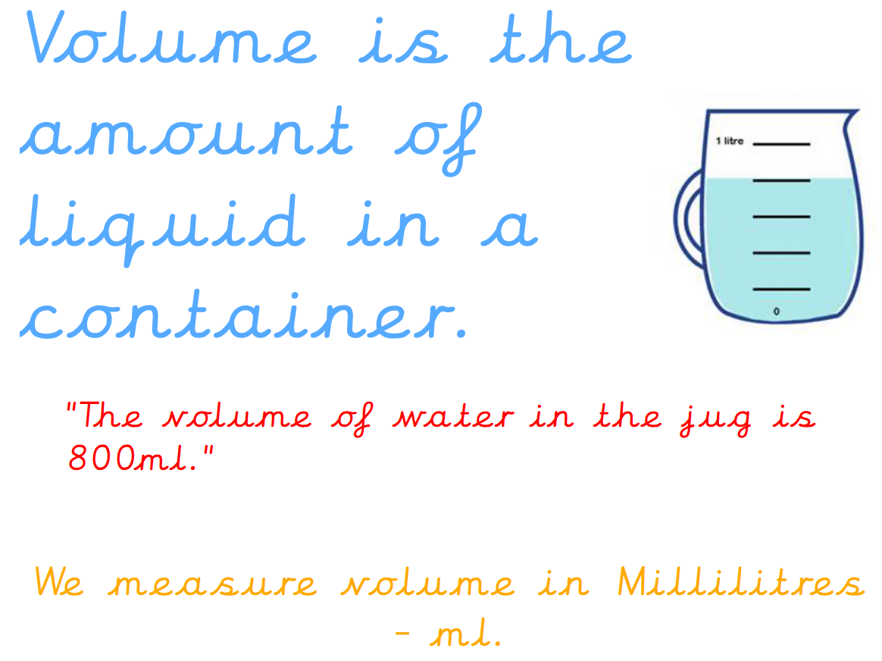

Can your child record under each glass whether the volume is full, half full or empty?

The children’s topic this half term is ‘Rio De Vida’. As part of topic lessons, children have started their geography learning. The children were shown a suitcase full of objects from around the world and had to guess what they were learning about – the seven continents and five oceans! The children know that a continent is a word used to ‘describe large areas of land’ and that the surface of the planet is approximately 70% water. Their first activity was to research a continent or an ocean in groups and design their own poster all about their chosen continent, which they then presented to the rest of their class. In the next lesson, children were given a coloured map of the world and their own blank map of the continents and oceans containing a key. They had to locate each continent and ocean on the world map and colour it in the same colour, as well as on their key. We then learned about directions North, East, South and West. We discussed this in relation to the continents whilst looking at a world map. For example, Asia is to the East of Europe.

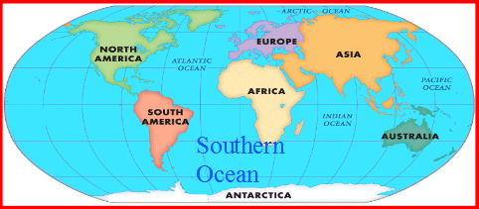

Can your child tell you which continent is North of South America?
Can your child tell you which continent Brazil is in?

Reminders:
Class 7 PE days are Monday and Tuesday.
Class 8 PE days are Monday and Tuesday.

Attendance for KS1:
Class 7 – 0%
Class 8 – 0%

Homework
Homework will mainly be handed out on a Wednesday. On the odd occasion it may be on a different day due to timetable changes. Please return homework on a Monday. Handing it on a Monday gives you the opportunity before the weekend to ask the teacher any questions so that you are clear of how to support your child if unsure. There is a tray in each class where the homework needs to be returned. Please ask the teacher where this tray is if unsure.

Spellings
Spellings are handed out each Thursday and your child will be tested on these spellings the following Thursday. Children will receive a list of spellings to practise each week. In addition to the spellings, children will be tested on a sentence containing the words. However, the sentence will not be sent home. This is to see if they can apply the spelling currently within their writing. Can you get your child to practise applying the words by creating their very own sentences?

Reading Diaries
Children in KS1 have all been provided with a Home Reading Diary. Please fill this in daily based on your child reading a couple of pages of a book or a whole book. Please return the Reading Diary to school each day and leave it in the designated classroom tray. There are books situated in the classroom for your child to take home daily. Reading is extremely important to your child’s development so we really encourage your child to read a book or pages of a book daily. If you are unsure of your child’s reading book colour then please ask your teacher.

Thank you
Miss Bamford & Miss Payne

