2 Year Provision Newsletter – w/c 18/12/23
Last week

Last week in our 2 year provision we have been very busy doing our Christmas craft getting the children into the spirit ready for Christmas! The children have also enjoyed doing various Christmas themed activities, such as Santa’s workshop, writing letters to Santa and playing in the Christmas themed small world area.

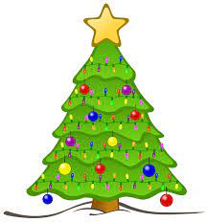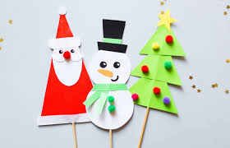

This week  On Tuesday and Thursday, we will be having our Christmas Party. Children are to bring some party food to eat on the day(no nuts please due to food allergies). They can come dressed up in fancy dress or a Christmas jumper. There will also be a visit from Santa.  On Wednesday we are having our stay and play. There is one session in the morning and one in the afternoon. There will be a carousel of craft activities for you to enjoy doing with your child.  We will also be saying a goodbye to our children who are going into nursery in January, we will miss you and wish you well on this new adventure! | Book of the week  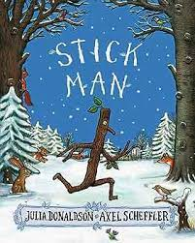  This story is linked to our theme we are running this week. Maybe if you have this story at home you could look though the story together at bedtime.  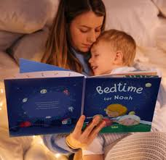
Dates for your diary
Tuesday 19th December – Christmas Party pm
Wednesday 20th December – Christmas Stay and Play
Thursday 21st December – Christmas Party pm
Friday 22nd December – Christmas Jumper Day pay £1 - last Day
School Returns Monday 8th January 2024

From Everyone in 2-year provision we would like to wish you all a very Merry Christmas and a Happy New Year!

Reminder
Please remember to ensure all your child’s clothing and water bottles are labelled and if you could provide spare clothes in their bag as we are very low on spare clothes.

Please ensure your child brings a warm coat, hat and gloves. We will be playing out in all weathers so if you would like to provide them with some wellingtons in a labelled carrier bags as we have some large puddles which develop when it rains heavy and children love to jump in muddy puddles!

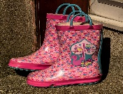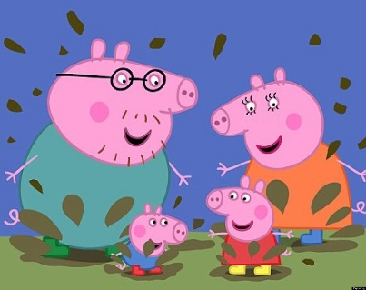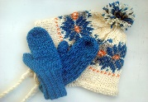
This Photo by Unknown Author is licensed under CC BY-NC-ND
This Photo by Unknown Author is licensed under CC BY-NC-ND

