2 Year Provision Newsletter
– w/c 29/01/24
Last week
Last week in provision we continued doing activities around our theme, where does the snow go. The children enjoyed watching the ice melt and how cold it made the water.
This week  We are continuing our topic, “Where does the snow go?” We are doing various activities around this and linking it to cold countries with the weather being cold.  It is also ‘safety week’ so we have various activities for the children to do around this topic. | Book of the week  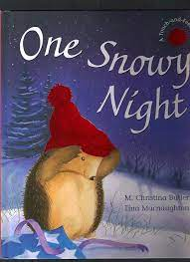  This story is linked to our theme we are running this term. Maybe if you have this story at home you could look though the story together at bedtime.
Dates for your Diary
W/C 29th January – Safety week, we will be having visitors come in to school such as Jackie our lollipop lady to talk about keeping ourselves safe when crossing the road.
Stay and Play – Tuesday 30th January & Wednesday 31st January at 2.15pm
Half term Is from Friday 9th February to Monday 19th 2024

Reminder
A gentle reminder about only providing water in water bottles. Thank you.

Please ensure your child brings a warm coat, hat and gloves. We will be playing out in all weathers so if you would like to provide them with some wellingtons in a labelled carrier bags as we have some large puddles which develop when it rains heavy and children love to jump in muddy puddles!
This Photo by Unknown Author is licensed under CC BY-NC-ND

Please remember to ensure all your child’s clothing and water bottles are labelled and if you could provide spare clothes in their bag as we are very low on spare clothes.
Thank you!

