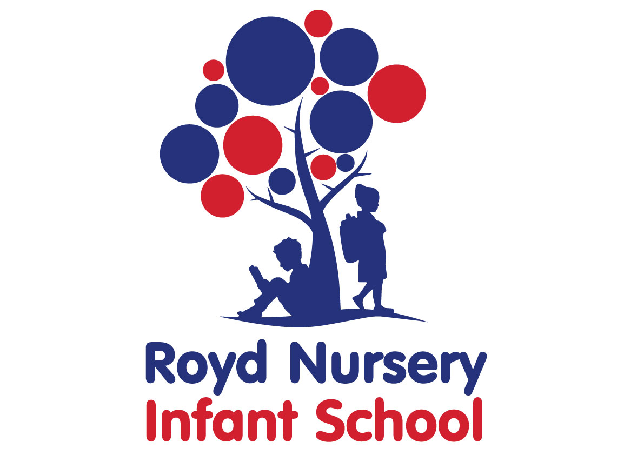

Policy: School Uniform

Adopted by Governing Body on | Sept 2023
Headteacher | L Jones
Date of Review | Sept 2024
Contents:
Statement of intent
- Legal framework
- Roles and responsibilities
- Cost principles
- Equality principles
- Complaints and challenges
- School uniform supplier
- Uniform assistance
- Non-compliance
- School uniform
- Adverse weather
- Labelling and lost property
- Monitoring and review

Statement of intent
Royd Nursery Infant School believes that a consistent school uniform policy is vital to promote the ethos of the school and provide a sense of belonging and identity for all pupils, regardless of their protected characteristics or socio-economic circumstances.
For the purposes of this policy, “uniform” includes the following elements of pupils’ appearance:
- Clothing, including the school uniform itself, variations of the school uniform such as PE kits, and other clothing worn at school, e.g. non-uniform.
- Hairstyles and headwear.
- Jewellery and other accessories.
This policy lays out the measures the school has taken to ensure a consistent, fair and inclusive uniform policy, and to implement a uniform that reflects the needs of all pupils, is affordable, and provides the best value for money for both the school and pupils’ families.
We believe that pupils learn most effectively and achieve their best outcomes when they are comfortable, able to be themselves, and dressed in a way that sets an appropriate tone for education.
Uniform is an expectation from FS1/ Nursery onwards. Children that attend the two year old provision are welcome to wear the uniform but it is not an expectation. Pull up trousers are encouraged to support potty training in this provision.

Legal framework
This policy has due regard to all relevant legislation and guidance including, but not limited to, the following:
- Human Rights Act 1998
- Education and Inspections Act 2006
- Equality Act 2010
- Education Act 2011
- The UK General Data Protection Regulation (UK GDPR)
- Data Protection Act 2018
- Education (Guidance about Costs of School Uniforms) Act 2021
- DfE (2021) ‘Cost of school uniforms’
- DfE (2021) ‘School Admissions Code’
- DfE (2021) ‘School uniforms’
- Equality and Human Rights Commission (2022) ‘Preventing hair discrimination in schools’

Roles and responsibilities
The governing board is responsible for:
- Establishing, in consultation with the headteacher and school community, a practical and smart school uniform that accurately reflects the school’s vision and values.
- Ensuring that the school’s uniform is accessible, inclusive, and does not disadvantage any pupil because of their protected characteristics or socio-economic status.
- Listening to the opinions and wishes of parents, pupils and the wider school community regarding changes to the school’s uniform.
- Ensuring that the school’s uniform is accessible and affordable.
- Demonstrating in this policy how best value for money has been achieved.
- Ensuring compliance with the DfE’s ‘Cost of school uniforms’ guidance.
- Processing and approving all eligible School Uniform Assistance Application Forms.
The headteacher is responsible for:
- Enforcing the school’s uniform rules on a day-to-day basis.
- Ensuring that teachers understand this policy and what to do if a pupil is in breach of the policy.
- Listening to the opinions and wishes of the school community in regard to the school’s uniform and making appropriate recommendations to the governing board.
- Providing pupils with an exemption letter as appropriate, e.g. for a pupil who has a broken arm and requires a loose-fitting shirt.
Staff are responsible for:
- Ensuring that pupils dress in accordance with this policy at all times.
- Ensuring that pupils understand why having a consistent and practical school uniform is important, e.g. school identity.
Parents are responsible for:
- Providing their children with the correct school uniform as detailed in this policy.
- Informing the headteacher if their child requires an exemption to the uniform rules for a period of time, with a reason why.
- Ensuring that their child’s uniform is clean, presentable and the correct size.
Pupils are responsible for:
- Wearing the correct uniform at all times, unless the headteacher has granted an exemption.
- Looking after their uniform as appropriate.
- Understanding and respecting why a school uniform is important to the school, e.g. school identity and community.

Cost principles
The school will ensure that its school uniform is affordable and accessible to all pupils, and does not place an unreasonable financial burden on parents.
In accordance with the ‘School Admissions Code’, the headteacher will ensure that the school’s uniform requirements do not discourage parents from applying for a place for their child.
The school will assess the overall cost implications of its uniform policy regularly, including prior to making any changes to the school uniform. When evaluating whether costs are reasonable and proportionate, the school will take into account the opinions and situations of:
- Economically disadvantaged parents.
- Parents with multiple children who are, or will be in the future, pupils at the school.
- Parents of younger children, as they are likely to grow quickly and require new sets of uniform more frequently.
- Parents of pupils with protected characteristics that may impact their ability to access the uniform.
- LAC and PLAC.
The school will evaluate the cost of its uniform based on the overall collection of uniform items that parents would need to purchase for a pupil, rather than on the cost effectiveness of individual items; this will include consideration of the fact that parents will need to purchase multiples of certain items, e.g. shirts and socks, to ensure their child can come to school in clean uniform every day.
The school will keep branded uniform items to a minimal level that is reasonable for all members of the school community. The school defines a branded uniform item as any item of clothing that cannot be purchased at a range of retailers, e.g. supermarkets, due to the item’s logo, colour, design, fabric or other unique element. Where the school requires an item of branded clothing, it will assess how prices can be kept as low as possible and put measures in place to facilitate this. This may include:
- Offering sew- or iron-on logo patches for jumpers and cardigans that can be bought at non-specialist retailers, instead of requiring specific branded jumpers.
- Ensuring branded items are longer-lasting and unlikely to be grown out of quickly
- Making donated second-hand uniform available for purchase at a lower price or for free
The school will meet the DfE’s requirements and recommendations on costs and value for money. Care will be taken to ensure that school uniform is affordable for all current and prospective pupils, and that the best value for money is secured through reputable suppliers.
The school will work with multiple suppliers to obtain the best value for money possible. Any savings negotiated will be passed to parents where possible. The school will not enter into exclusive single-supplier contracts or cash-back arrangements. More information on supplier processes can be found in the ‘School uniform supplier’ section of this policy.
The school will not make frequent changes to uniform requirements and will take the views of parents and pupils into account when considering any changes.

Equality principles
The school takes its legal obligation to avoid unlawfully discriminating against any protected characteristic very seriously. In line with this, the school will aim to ensure that its uniform policy is as inclusive as possible so that all pupils can access a school uniform which is comfortable, suitable for their needs, and reflects who they are, while avoiding any direct or indirect discrimination on the basis of protected characteristics or socio-economic status.
The school will ensure that parents and pupils are consulted over any changes to school uniform, and that, where appropriate and with pupils’ consent, views and advice are sought specifically from pupils, and parents of pupils, who:
- Are transgender or non-binary.
- Are of a religious or cultural background that has specific dress requirements.
- Have SEND and/or sensory needs.
Parents’ concerns and requests regarding school uniform and amendments to it are handled on a case-by-case basis by the headteacher and governing board, and always in accordance with the school’s Complaints Procedures Policy.
Information on how the school ensures its uniform policy does not discriminate against pupils with specific protected characteristics is outlined below.
Gender
To avoid disproportionately impacting pupils of a certain gender, the school will ensure that the cost of uniform is as equal in price as possible across items for all genders.
This includes:
- Adhering to the procedures laid out in the ‘Cost principles’ section of this policy.
- Not directly requiring pupils of a certain gender to buy additional uniform, e.g. by requiring female pupils to buy both trousers and skirts.
- Not indirectly requiring pupils of a certain gender to buy additional uniform
- Not holding pupils of different genders to different uniform standards
The school will implement a gender-neutral uniform, meaning that pupils will not be required to wear specific items based on their gender, and may wear any of the uniform items listed in the ‘School uniform’ section of this policy regardless of the legal sex recorded on the school’s records. Transgender pupils are supported to access the uniform that best reflects their gender expression.
Religion and belief
To avoid disproportionately impacting pupils of a certain religion, belief or culture, the school will ensure that there is flexibility to allow pupils to present themselves in a way that adheres to their dress requirements as far as possible, within the school’s uniform policy.
The school will endeavour to meet all requests for amendments to the uniform for these purposes; however, the needs and rights of individual pupils will be weighed against any health and safety concerns appropriate to the circumstances, e.g. if safety headgear needs to be worn.
Race
To avoid disproportionately impacting pupils of a certain race, the school will ensure that its uniform policy does not constitute unlawful indirect discrimination through blanket rules. This includes:
- Not banning hairstyles related to a pupil’s ethnic origin, e.g. natural Afro hairstyles.
- Not banning hairstyles worn because of cultural, family and social customs, e.g. cornrows.
- Not banning head coverings related to a pupil’s culture or ethnic origin, e.g. African heritage head wraps.
The school will follow the good practice guidance provided by the Equality and Human Rights Commission on ‘Preventing hair discrimination in schools’.
SEND and medical conditions
To avoid disproportionately impacting pupils with SEND or medical conditions, the school will ensure its uniform policy takes into account the needs of these pupils. This includes:
- Ensuring the school uniform uses soft, stretchy fabrics and avoids intricate buttons or hard seams.
- Allowing variations to the standard uniform for pupils whose medical conditions may impact how they dress, e.g. pupils with casts who require loose-fitting clothing or pupils with hair loss-related conditions who wish to wear head coverings.
Where the needs of these pupils cannot be met in the standard uniform policy, individual adaptations to the uniform will be considered and permitted wherever possible.

Complaints and challenges
The school will endeavour to resolve all uniform complaints and challenges locally and informally, in accordance with the school’s Complaints Procedures Policy.
The school will refer individuals who wish to complain to the Complaints Procedures Policy and request that they follow the procedures outlined therein.
When a complaint is received, the school will work with the complainant to arrive at a mutually acceptable outcome.

School uniform supplier
The school’s current school uniform supplier is:
Price & Buckland
Benneworth Close
Hucknall
Nottingham
NG15 6EL

0115 964 0827
sales@price-buckland.co.uk
.
The governing board will ensure that a written contract is in place with the supplier for branded items. The school will retender the uniform contract every five years, whether changes to the uniform are made or not, in line with the Tendering and Procurement Policy.
The governing board will be able to demonstrate how uniform is procured at the best value for money. The headteacher will work to ensure that the items are procured as cheaply as possible without compromising on the quality, e.g. by requesting standard-style items from the supplier rather than more intricate and unique designs.
The school will not sign contracts with suppliers before requesting visualisations and samples of proposed uniform.
The school will order new uniform each Summer Term. Where the school is proposing to change suppliers, it will reach out to suppliers by October in the determination year.

Uniform assistance
The school will hold second-hand school uniforms in the school office for parents to access; access to these uniforms will be made available upon request made to the headteacher.
Parents will be invited to donate their child’s uniform when they no longer need it.

Non-compliance
Staff will contact parents when there are uniform breaches. Parents will be given a period of time to rectify the issue. Pupils will be reminded verbally the items that are permitted as school uniform.

School uniform
The school uniform is as follows:

Item | Optional or required | Branding | How to acquire | Cost per item from school supplier
Regular school uniform
Royal blue sweatshirt  Cardigan | Required | School logo on right-hand side | Branded sweatshirt and cardigan available from school office  second-hand available from school office for a small donation | £10.00  £11.00
White or pale blue polo shirt | Required | Branded and non-branded | Available from regular retailers, school office and second-hand from school office for a small donation | £8.50
Grey trousers, skirt, pinafore or shorts | Required | No branding | Available from regular retailers and second-hand from school office | Range of prices
Blue gingham dress | Optional in summer | No branding | Available from regular retailers | Range of prices
Sensible, plain black shoes or trainers | Required | No branding | Available from regular retailers | Range of prices
Dark grey or black leggings | optional | No branding | Available for regular retailers | Range of Prices
White, dark grey or black socks/tights | Required | No Branding | Available from regular retailers | Range of prices
PE kit
Plain white t-shirt | Required | No branding | Available from regular retailers | Range of prices
Plain navy shorts/PE skirt  PE kit in a bag  Shorts & top with logo | Required | No branding | Available from regular retailers  Available from school office | Range of prices  PE kit in a bag £13.00
Plain trainers/plimsolls (indoor) | Required | No branding | Available from regular retailers | Range of prices
Jogging bottoms and sweater/hoodie for outdoor PE | Required for outddor PE at colder times of the year | No branding | Available from regular retailers | Range of prices

The following items are not permitted:
Tracksuit bottom and cycling shorts as school uniform
Patterned tights
Denim shorts/ skirts, trousers
Strappy sandals, high heels, crocs
Parents who do not wish to buy the optional branded PE kit must acquire a PE kit meeting the following criteria:
PE kit:
- Plain T-shirt with no branding or logos from professional sports teams
- Plain shorts or tracksuit bottoms with no branding or logos from professional sports teams
- Suitable trainers
Parents are responsible for ensuring their child brings their PE kit to school when needed.
Jewellery
The school rules on jewellery are as follows:
- One pair of stud earrings may be worn – no other piercings are permitted. Must be removed if possible for PE
- A smart and sensible wrist watch may be worn.
Pupils will be advised that jewellery is their personal responsibility and not that of the school. Lost or damaged items will not be refunded. All jewellery must be removed during practical lessons, including PE lessons and science experiments.

Bags
Pupils must use an appropriately-sized waterproof bag to carry their books, belongings and equipment.
School bags featuring inappropriate images, slogans or phrases will not be permitted.
The school will discourage pupils from bringing valuable bags to school. The school will not be liable for lost or damaged school bags.
Hairstyles and headwear
The school reserves the right to make a judgement on whether a pupil’s hairstyle, hair colour or headwear is inappropriate for the school environment; however, the school will ensure that any such judgements do not discriminate against any pupil by virtue of their protected characteristics. Each individual pupil’s scenario will be taken into account where any judgements on appropriateness are to be made, and parents will always have the freedom to complain via the school’s Complaints Procedures Policy.
Pupils with long hair must ensure that this does not impede their vision, cover their face, or cause a health and safety risk. Long hair must be tied up during practical lessons, e.g. during PE.
The following hairstyles, hair colours and headwear are not considered appropriate for school:
- Brightly-coloured dyed hair
- Excessive hair accessories
- Headwear featuring inappropriate words or images

Adverse weather
All pupils will be advised to wear weather-appropriate clothing.
For hot temperatures, this includes wearing:
- Tops that cover the shoulder area.
- Sunglasses with UV protection when outside.
Pupils will be advised not to wear any jumpers or blazers during heatwaves. If outside during break times, pupils not wearing sun-safe clothing will be advised to stay in an area protected from the sun, or spare clothing is provided.
For cold temperatures, this includes wearing:
- Scarfs, gloves, coats and hats when outside.
- Warm jumpers.
- Trousers, or skirts and thick tights.

Labelling and lost property
Parents will be advised to ensure that all pupils’ clothing and footwear is clearly labelled with their name and year group.
Any lost clothing will be taken to the lost property box in the school hall. All lost property will be retained for one term and will be disposed of if it is not collected within this time.

Monitoring and review
This policy will be reviewed annually by the chair of governors and the headteacher. The next scheduled review date for this policy is September 2024.
Any changes to this policy will be communicated to all staff, pupils, parents and other relevant stakeholders.

