This Week
Baby Announcement
Miss Terry has given birth to a beautiful baby boy. Albie George was born on 30th January 2024 at 10.07am and 7lb 7oz. Both Mum and baby are well. The children were thrilled to hear the news!
This week we have continued to explore the story ‘The Firefighter’. The children have loved acting out the story! This week has also been safety week across school. We have had a visit from Jackie our lollipop lady. She has been in to see the children and teach them all about road safety and how to cross a road safely. They loved practising this on our pretend road. In phonics this week, the children have learnt some new sounds with their peers, where they have had to hear and say the sound and then practice writing it. We have been focusing on our mark making skills this week. Children have had to make marks, making thank you cards. They loved telling us all about their cards for their special people in their lives that help them.
This week Class 5 attendance- 87.6%
Next week…  Next week we will be starting to look at a non-fiction text called ‘Winter’. We will be exploring the book, looking at the pictures and discussing what we have learnt from the information. Our focus will be around mark making next week where we will be writing a list of things we want to buy from the ‘Royd Winter shop’.  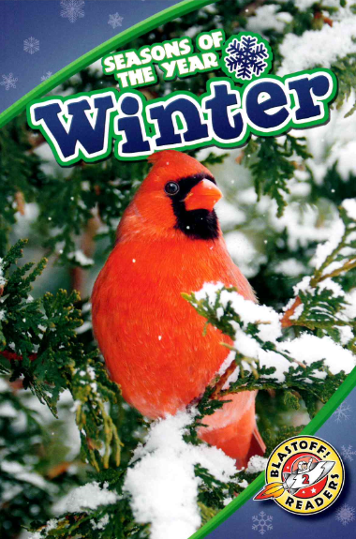  Phonics:  Next week Mrs Musgrave’s phonics group will focus on the sounds: p and g.  Miss Hosford’s phonics group will focus on the sounds: e and l  Mrs Bailey’s group will focus on the sound s.  Stay and play:  Tuesday 6th 2.15pm- 3pm. Please be advised if you do attend the stay and play, you can take your child home once this has finished.  A member of staff the Family Intervention Services (FIS) specialising in the early years will be attending both sessions. As a service they can offer a range of advice from behaviour, routines, sleep and toileting. Between 2.15pm and 2.55pm they will have a table set up within the nursery for parents / carers to have an informal discussion should you wish to approach them and ask them any questions or seek any advice. Between 2.55pm and 3.10pm the member of staff from the Family Intervention Services (FIS) will host a 15 minute session with parents / carers discussing what the service can offer. This allows Nursery staff to get children ready in preparation for home time and allows parents / carers to be in the warm rather than standing outside in the cold waiting. We hope that you find this useful. | Stars of the week  Mrs Musgrave- Edith for lovely manners in nursery and always having a smile on her face.  Mrs Phillips- Otie for becoming independent since joining nursery.  Mrs Bailey- Rowan R for being a super star at tidy up time and for helping the adults around her.
Homework
Homework will be given out to children on their last day of every week.
If you have lost your homework or did not receive one due to absence, please collect your own copy from the notice board in the entrance to Nursery.
Reading books
Children in Nursery are encouraged to select a book from the book box next to the peg area. Children should keep the same book for a week and return these on their last day of Nursery every week. Please ensure you change your child’s book with them in the morning. Please also note that unless the previous book is returned, a new book cannot be issued to your child until it has been returned.
Reminders
Please ensure you encourage your children to organise themselves in the morning with their cloakroom. We are working really hard on building up independence ready for children to start school in September.
If your child does require to be changed in a nappy, please ensure you have enough wipes, nappies and disposable bags packed, for the next term as Nursery do not provide these.
Please ensure your child is wearing appropriate clothing at this time of year. We have a lot of children who come to Nursery not having gloves, hats or scarves. We do play outside in all weathers and are very short on spares for this to offer.
Thank you.

