

Royd Nursery Infant School

Carr Road, Deepcar

Sheffield, S36 2PR

Tel 0114 288 2594

Email [enquiries@royd.sheffield.sch.uk](mailto:enquiries@royd.sheffield.sch.uk)

[www.roydnurseryinfants.co.uk](http://www.roydnurseryinfants.co.uk)

Headteacher: Louise Jones

1 February 2024

Dear Parents/Carers

For children in FS2, Y1 and Y2 we are running several extra curricular activities during the Spring 2 half term.

Learn Different Sports continues this term and includes tennis, cricket, rugby, hockey and basketball. We also have basketball/netball on a Friday. The Friday club is for 5 weeks as Friday 29 March is Good Friday and school will be closed.

For your child to attend, you will need to log on to Parentpay then select and pay for the club/s you wish your child to attend. This will be on a first come first served basis and the places become available later today.

Thank you.

Yours sincerely,

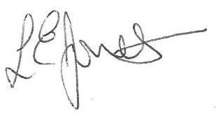

Louise Jones Sean Sly

Executive Head Acting Deputy Head

-------------------------------------------------------------------------------------------------------------------  
**Extra Curricular Activities Spring 2 2024**

**Monday**

Learn Different Sports FS2/Y1/Y2 3.20pm – 4.20 pm 19 Feb – 25 Mar £24

**Tuesday**

Dance FS2/Y1/Y2 3.20pm – 4.20pm 20 Feb – 26 Mar £24

**Wednesday**

Football Y1//Y2 3.30pm – 4.30pm 21 Feb – 27 Mar £24

**Friday**

Basket/Netball FS2/Y1/Y2 3.20pm – 4.20 pm 23 Feb – 22 Mar £20





