

Royd Nursery Infant School

Carr Road, Deepcar

Sheffield, S36 2PR

Tel 0114 288 2594

Email [enquiries@royd.sheffield.sch.uk](mailto:enquiries@royd.sheffield.sch.uk)

[www.roydnurseryinfants.co.uk](http://www.roydnurseryinfants.co.uk)

Headteacher: Louise Jones

22 February 2024

Dear Parents / Carers

We would like to invite you in to School for a Stay and Play session with your child on Thursday 29th February 2024.

There will be a carousel of activities celebrating Chinese New Year. The session will be from 2:15 pm until 3:00 pm.

Please complete and return the slip below or email [enquiries@royd.sheffield.sch.uk](mailto:enquiries@royd.sheffield.sch.uk) if you would like to join us. It would be lovely to see you all.

Yours sincerely,

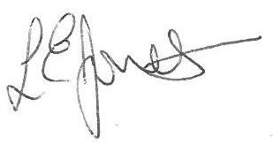

Louise Jones Sean Sly

Executive Head Acting Deputy Head

**Reception Stay and Play 29 February 2024**

Name of child : Class:

Yes I / We would like to join you for the Stay and Play

No I / We are unable to attend.

Signed ____________________________________________________ Parent/carer



