Newsletter February 2024

Staffing changes/News
We are pleased to share that Miss Terry had a healthy baby boy weighing 7lb 7oz. He has been named Albie. Mum and baby are doing well.

Mr Horner got married at the start of the February half term. I am sure you will join me in congratulating them both.

Jungle Book
After the success of the pantomime we have booked in a travelling theatre company to come into school to perform for children between Reception and Y6. A letter will follow with further information.

Two Year old Provision
We have a few spaces left for starters after Easter. Please contact the school office at Royd if you or anyone you know is interested.

Upcoming Childcare Changes
You will have heard in the news about changes being phased in for free childcare that the government announced last year. Below is some information so you are aware of what your entitlement is for a two year old child. There are no changes for 3-4 year olds.

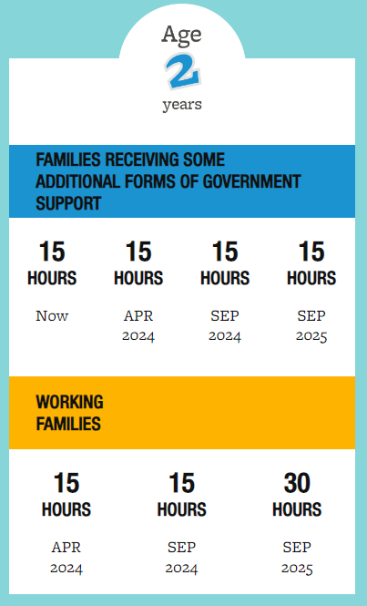

If you have a child that will be two in the coming year and you would like for them to attend our provision please contact school. This will enable us to plan ahead as much as possible with our staffing. Thank you.

Inset days
The remaining curriculum days this academic year are as follows:
Monday 22 July 2024
Tuesday 23 July 2024

Parents Evening
Please see the dates below. Please remember that if your child is on the SEND register you do not need one of these appointments as you will have a structured conversation.

PE Kit
All children need to have a PE kit in school. This needs to be an indoor and an outdoor PE kit. Please look at the school websites for further details.

Attendance
We are trying really hard to improve attendance at both schools. Our aim is to get our overall attendance up to 96.5%. We are currently at 94.7% at Royd and 94.6% at St John’s. We really do need to improve. Every day at school counts. If your child is not feeling 100% in the morning please give them some medication and still bring them into school. Give them a chance to attend. We are great at looking after them and if they need to come home we will give you a call. Often, once they are in, they do feel better.

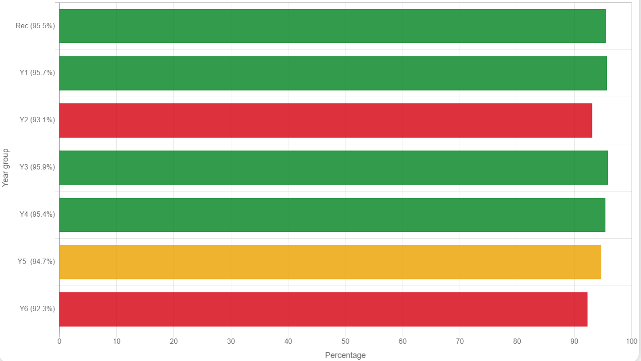

Parking
I have received numerous complaints from parents/carers about issues with parking around both schools and the danger this is posing to our children. Today I have been out with the School Council from St John’s and the children have placed yellow parking tickets on cars that they feel are obstructing drives, parked on corners where families cross roads, parked on double yellow lines and on grass verges. I have contacted the Parking Enforcement team who will be out on patrol in the next few days.

The school council are planning further walks to identify what they class as dangerous parking for our children. Let us hope you do not receive a ticket.

Breakfast and Afterschool club
Payment should be made upfront of this provision, please make sure your ParentPay account is in credit prior to booking a session. We are hoping to develop the provision further this next financial year and will be emailing parents/carers with a questionnaire to see what else they and their children would like to see in the wrap around care.
Dates for Diary
Royd Nursery Infant
February
29 – FS2 ‘Stay and Play’ – rearranged due
to snow
March
4 to 8 – 2 year and Nursery provision
World Book Day activities
7 - World Book Day – all school
13 - Storyteller in school- parents welcome
15 - Red Nose Day
21 – Parents Evening – all school
25 to 28 – 2 year and Nursery provision
Easter Activities
25 – Parents Evening Nursery only
26 – Structured Conversations
27 - Egg rolling and egg decorating
Competition
Parents Evening – all school
28 - Rock Steady concert 2pm
Structured conversations

April
19 - Theatre visit – Jungle book
Deepcar St John’s

March
6 - Parents Eve 4-6pm
7- Parents Eve (just MWB-Y5)
7- World Book Day
13- Parents Eve 3:30-5:30pm
15 - Red Nose Day

27- Egg rolling and egg decoration competition
28- Rock Steady concert 10am

April
19-Theatre visit- Jungle Book
24-26- Residential Y4 The Oakes

May
2- First aid training Y5

