23rd February 2024

RED NOSE DAY FRIDAY 15th MARCH 2024

This year we will again be joining in with the charity event comic relief - Red Nose Day.

If your child would like to, they can come to school wearing something red on Friday the 15th March for a donation of £1, £2 or £5. Payment will be available via your ParentPay account, and all monies raised will be sent to Comic Relief.

Unfortunately, we will not be selling red noses again this year but children are welcome to bring in a red nose for the day if they have one.

Kind Regards

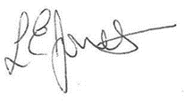
Miss L Jones
Executive Headteacher

