

Royd Nursery Infant School

Carr Road, Deepcar

Sheffield, S36 2PR

Tel 0114 288 2594

Email [enquiries@royd.sheffield.sch.uk](mailto:enquiries@royd.sheffield.sch.uk)

[www.roydnurseryinfants.co.uk](http://www.roydnurseryinfants.co.uk)

Headteacher: Louise Jones

2 February 2024

**Spring Storyteller Event**

Dear Parents/Carers

We are excited to tell you that we have a storyteller coming to Royd. Beth Guiver will be attending our school on Wednesday March 13 2024 **and delivering an interactive storytelling session.**

**Beth has an engaging and immersive style to ensure active participation full of magic, music and song! There will be a range of classic tales so children can take these stories with them into play and language and we** would like for parents/carers to join us to share the experience with your child/children. Please complete and return the slip below to school to let us know you are attending. The time of your child’s storytelling session are below:

2 Year Old (Mrs Jaques/Mrs Crofts) 13 March 2024 9:15 – 9:45

Nursery (Mrs Musgrave) 13 March 2024 9:45 – 10:25

Reception (Miss Brook/Miss Brown 13 March 2024 10:35 – 11:25

If your child does not attend their provision on this day parents/carers are welcome to bring your child and join the session. You will need to remain with your child due to ratio’s and school must be advised - thank you.

If you would like your child to take part, a contribution of £1.50 and consent is via Parentpay. Please complete this by Wednesday March 6. If there are any issues please do not hesitate to contact Mr Sly.

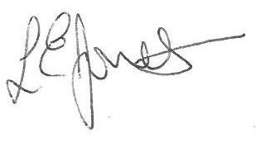

Louise Jones Sean Sly

Executive Head Acting Deputy Head

**Early Years Foundation Stage Storyteller - Wednesday 13 March 2024**

Name of child : Class:

Yes I / We would like to join you for the Soryteller

No I / We are unable to attend.

Signed ____________________________________________________ Parent/carer



